DAY – 1 DATA STRUCTURES PROGRAMS

1. Write a C program to find the given number is Even or Odd

Code:

#include<stdio.h>

int main(){

int n;

printf("Enter any positive number: ");

scanf("%d", &n);

if(n%2==0)

printf("The number is even");

else

printf("The number is odd");

return 0;

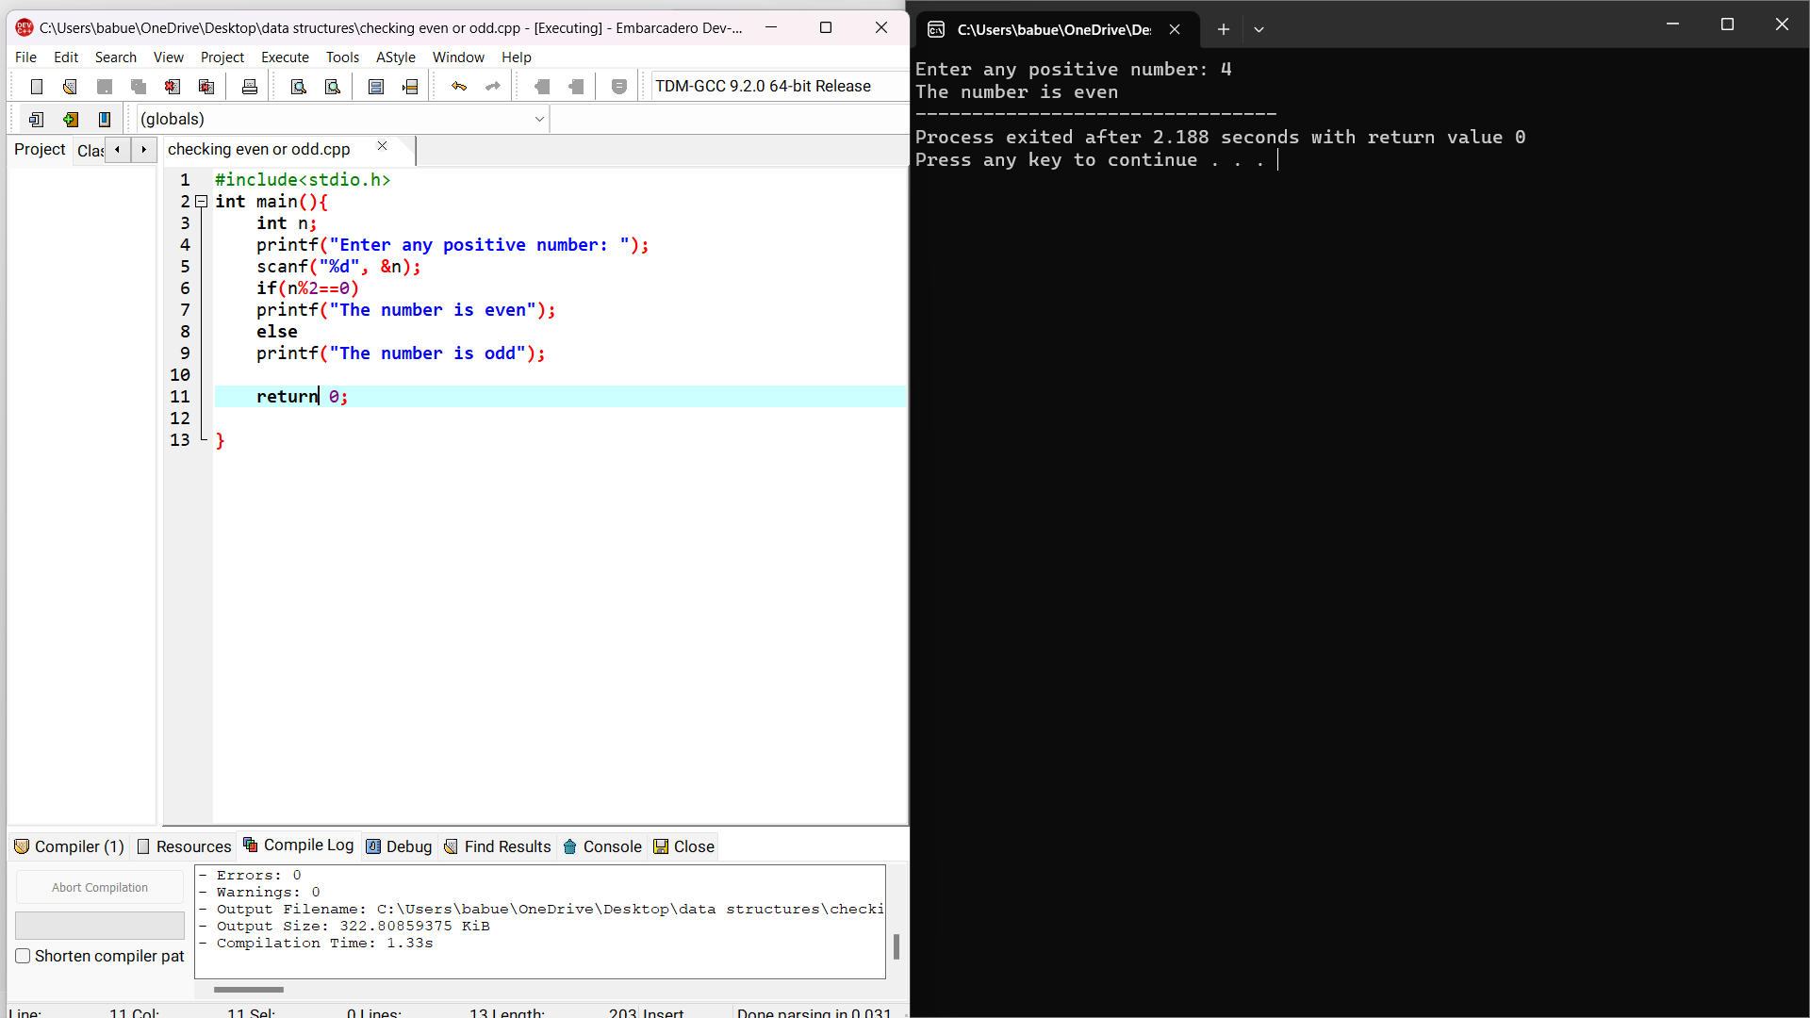 }

Sample input: 4

Output: The number is even.

1. Write a c program to find sum of first n numbers using any loop?

Code:

#include<stdio.h>

int main(){

int n, i, sum = 0;

printf("Enter any number: ");

scanf("%d", &n);

for(i = 1; i <= n; ++i){

sum += i;

}

printf("The sum of first n numbers is : %d\n", sum);

return 0;

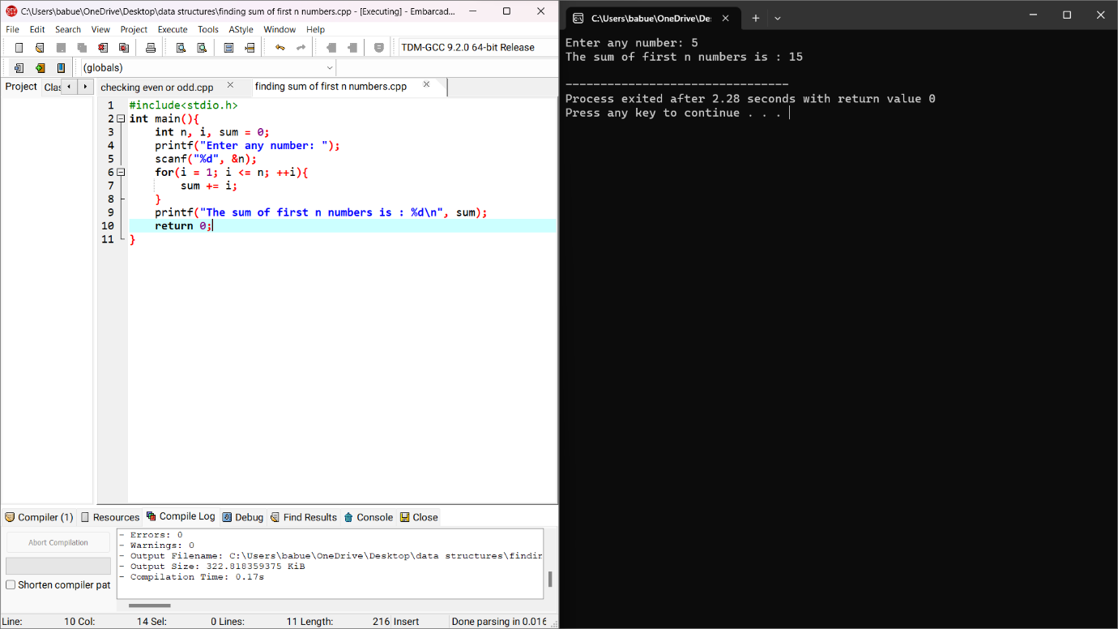}

Sample input = 5

Output : sum = 15

1. Write a C program to find sum of even numbers with first n numbers?

Code:

#include<stdio.h>

int main(){

int n, i, sum = 0;

printf("Enter any limit: ");

scanf("%d", &n);

for(i = 2; i <= n; i+=2){

sum += i;

}

printf("The sum of first n even numbers from 1 to %d : %d", n, sum);

return 0;

}

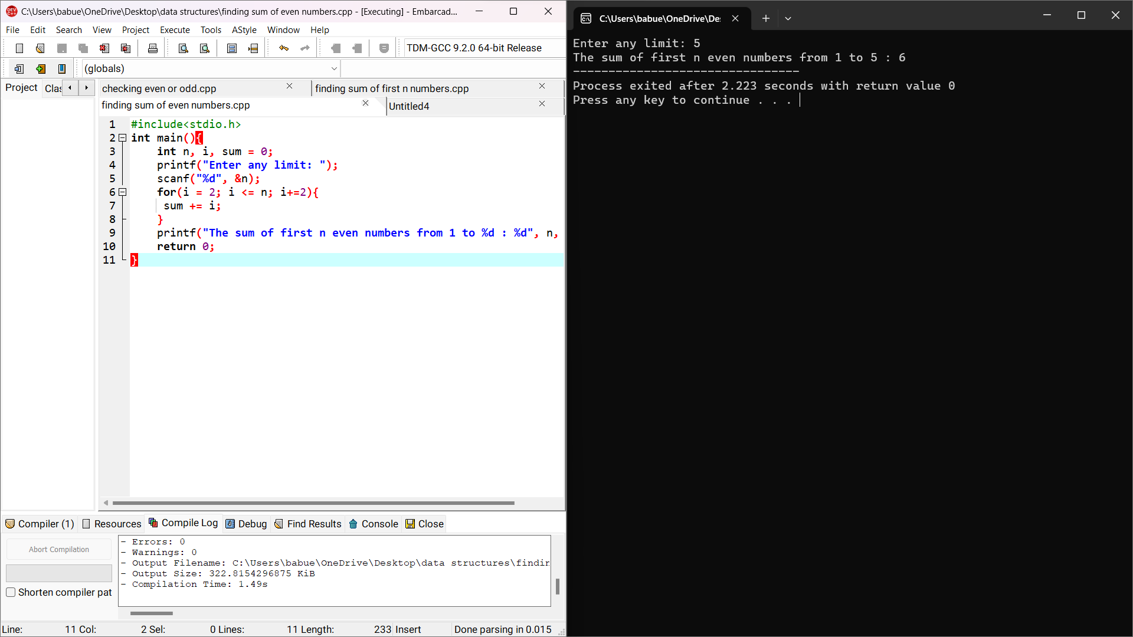

Sample input : 5

Output: The sum of first n even numbers from 1 to 5: 6

1. Write a C program to find sum of odd numbers the first n numbers?

Code:

#include<stdio.h>

int main(){

int n, i, sum = 0;

printf("Enter the limit: ");

scanf("%d", &n);

for(i = 1; i <=n; i++){

if(i % 2 != 0){

printf("%d\n", i);

sum = sum + i;

}

}

printf("The sum of Odd numbers from 0 to %d is: %d", n, sum);

return 0;

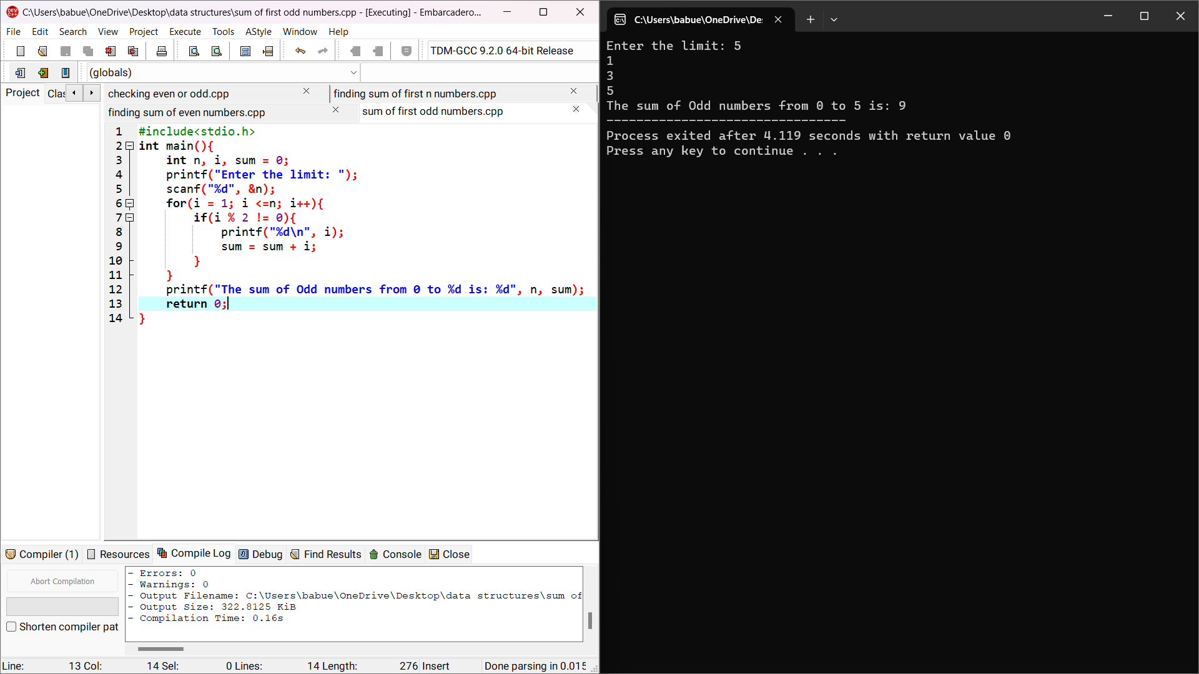}

Sample input: 5 and Output: 9

1. Write a C program to find the factorial of a given number with Recursion?

Code:

#include<stdio.h>

int fact(int n){

if(n == 1){

return n;

}

return n*fact(n-1);

}

int main(){

int n;

printf("Enter any positive number: ");

scanf("%d", &n);

printf("%d", fact(n));

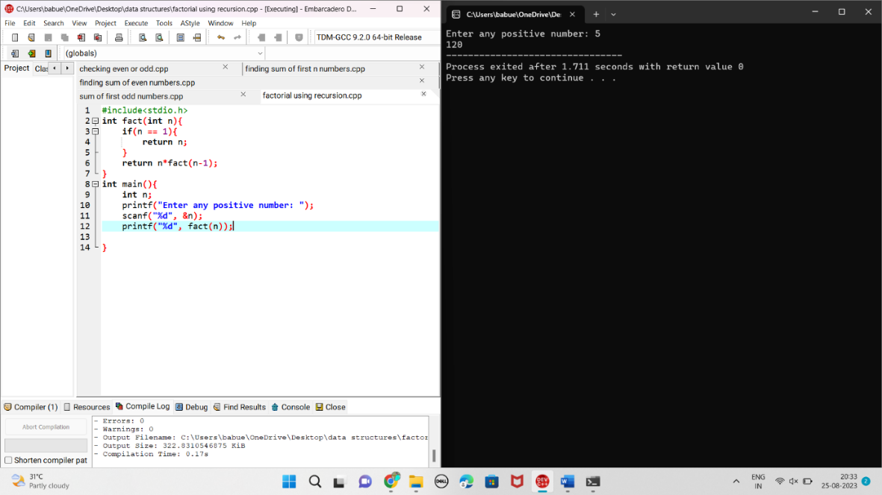}

Sample input: 5

Output : 120

1. Write a C program to find the factorial of a given number without Recursion?

Code:

#include<stdio.h>

int main()

{

int n,i,fact=1;

printf("Enter any number: ");

scanf("%d", &n);

for(i = 1; i <= n; i++){

fact = fact * i;

}

printf("The factorial of %d is : %d", n, fact);

return 0;

}

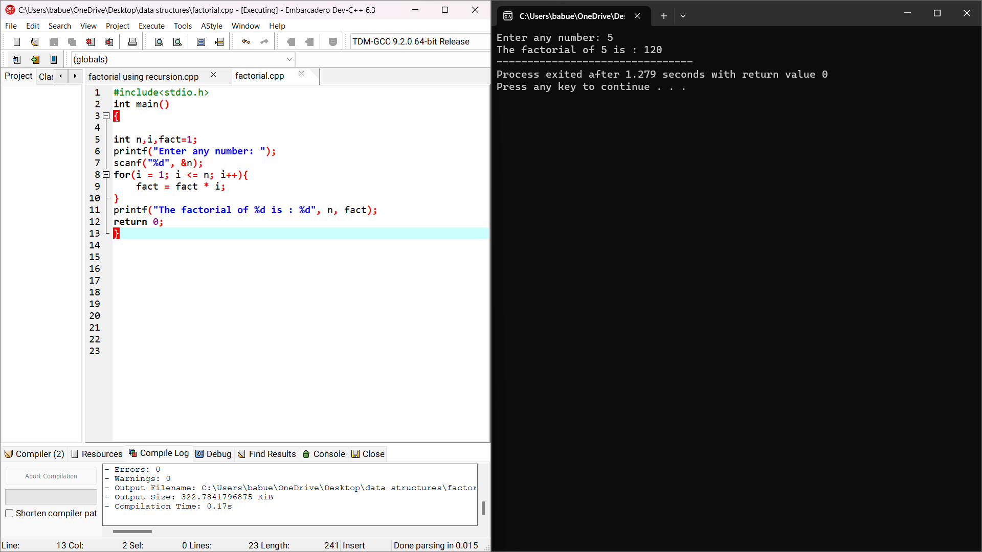

Sample input :5

Output: 120

1. Write a C program to find or to generate Fibonacci series with Recursion?

Code:

#include<stdio.h>

int main(){

int n1 = 0, n2 = 1, n3, i, number;

printf("Enter the number of elements : ");

scanf("%d", &number);

printf("\n%d%d", n1,n2);

for(i = 2; i < number; ++i){

n3 = n1 + n2;

printf("%d", n3);

n1 = n2;

n2 = n3;

}

return 0;

}

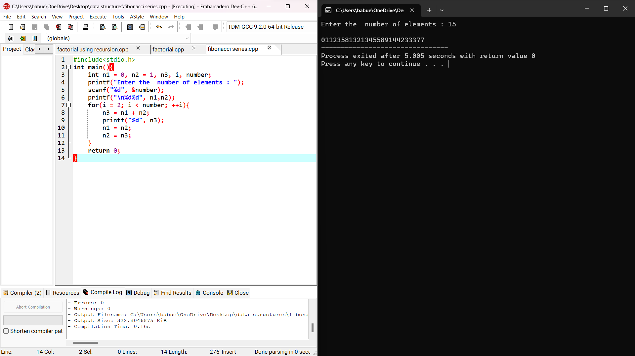

Sample input: 15

Output : 0 1 1 2 3 5 8 13 21 34 55 89 144 233 377.

8)Write a C program to generate Fibonacci series with recursion?

Code:

#include<stdio.h>

int fi(int n){

if(n == 0){

return 0;

}

else if(n == 1){

return 1;

}

else{

return(fi(n-1)+fi(n-2));

}

}

int main(){

int fi(int n);

int n, i = 0, c;

scanf("%d", &n);

printf("fibonacci series \n");

for(int c=1;c<=n;c++){

printf("%d", fi(i));

i++;

}

return 0;

}

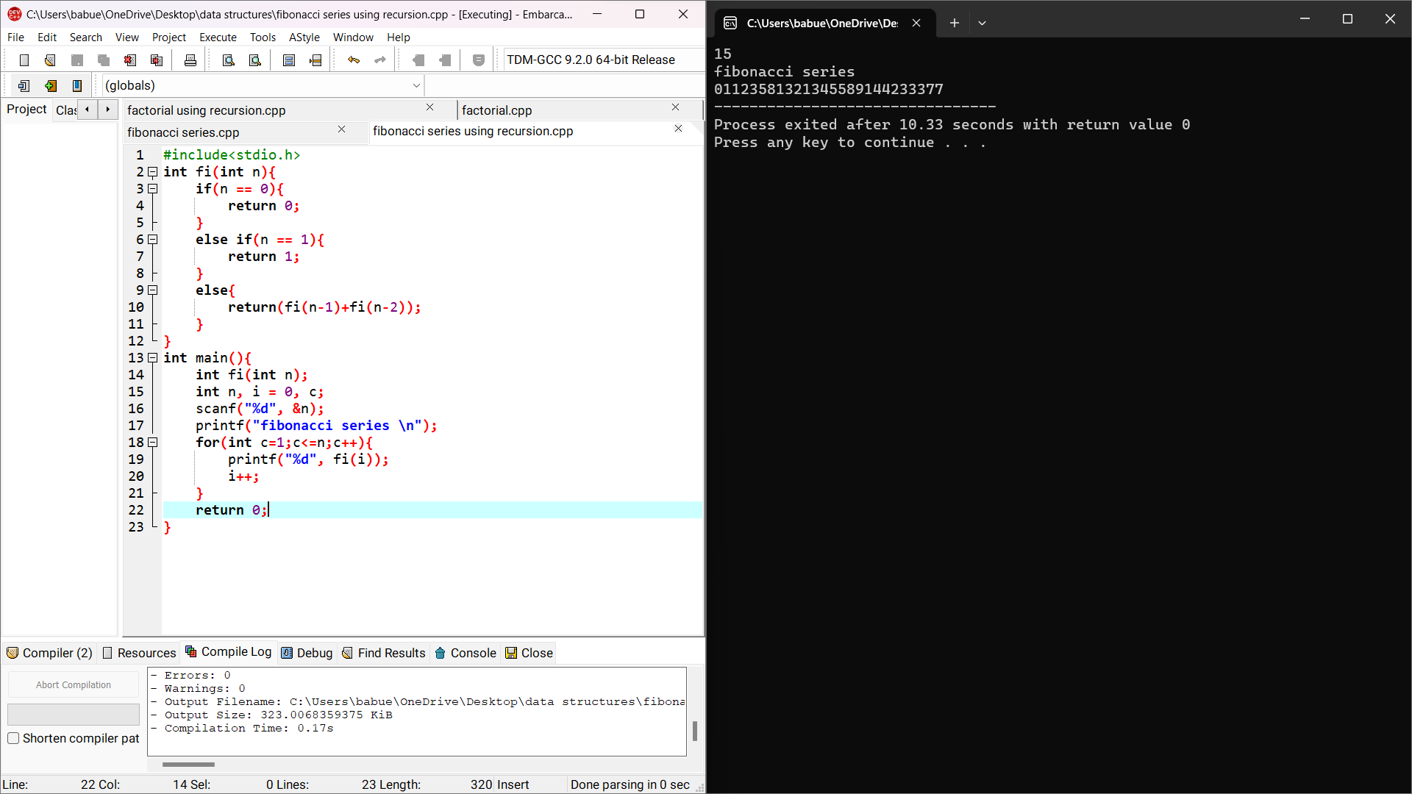

Sample input : 15

Output: 0 1 1 2 3 5 8 13 21 34 55 89 144 233 377.

9)Write a C program to reverse a given number?

Code:

#include<stdio.h>

int main(){

int n, reverse = 0, remainder;

printf("Enter any number: ");

scanf("%d", &n);

while(n != 0){

remainder = n % 10;

reverse = reverse * 10 + remainder;

n /= 10;

}

printf("Reversed number = %d", reverse);

return 0;

}

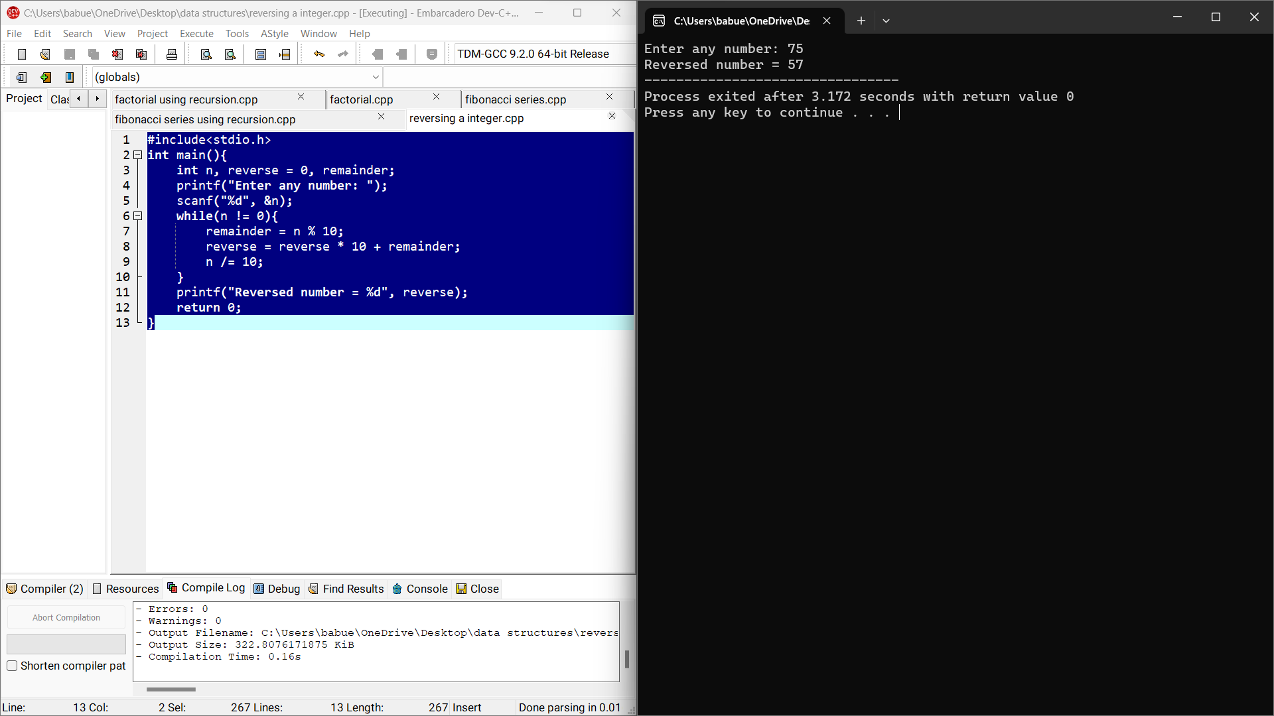

Sample input: 75

Output: 57

10) Write a C program to check palindrome or not?

Code:

#include<stdio.h>

int main()

{

int n, r, sum = 0, temp;

printf("Enter the number: ");

scanf("%d", &n);

temp = n;

while(n>0){

r = n%10;

sum = (sum*10)+r;

n = n/10;

}

if(temp==sum)

printf("Palindrome number");

else

printf("not palindrome");

return 0;

}

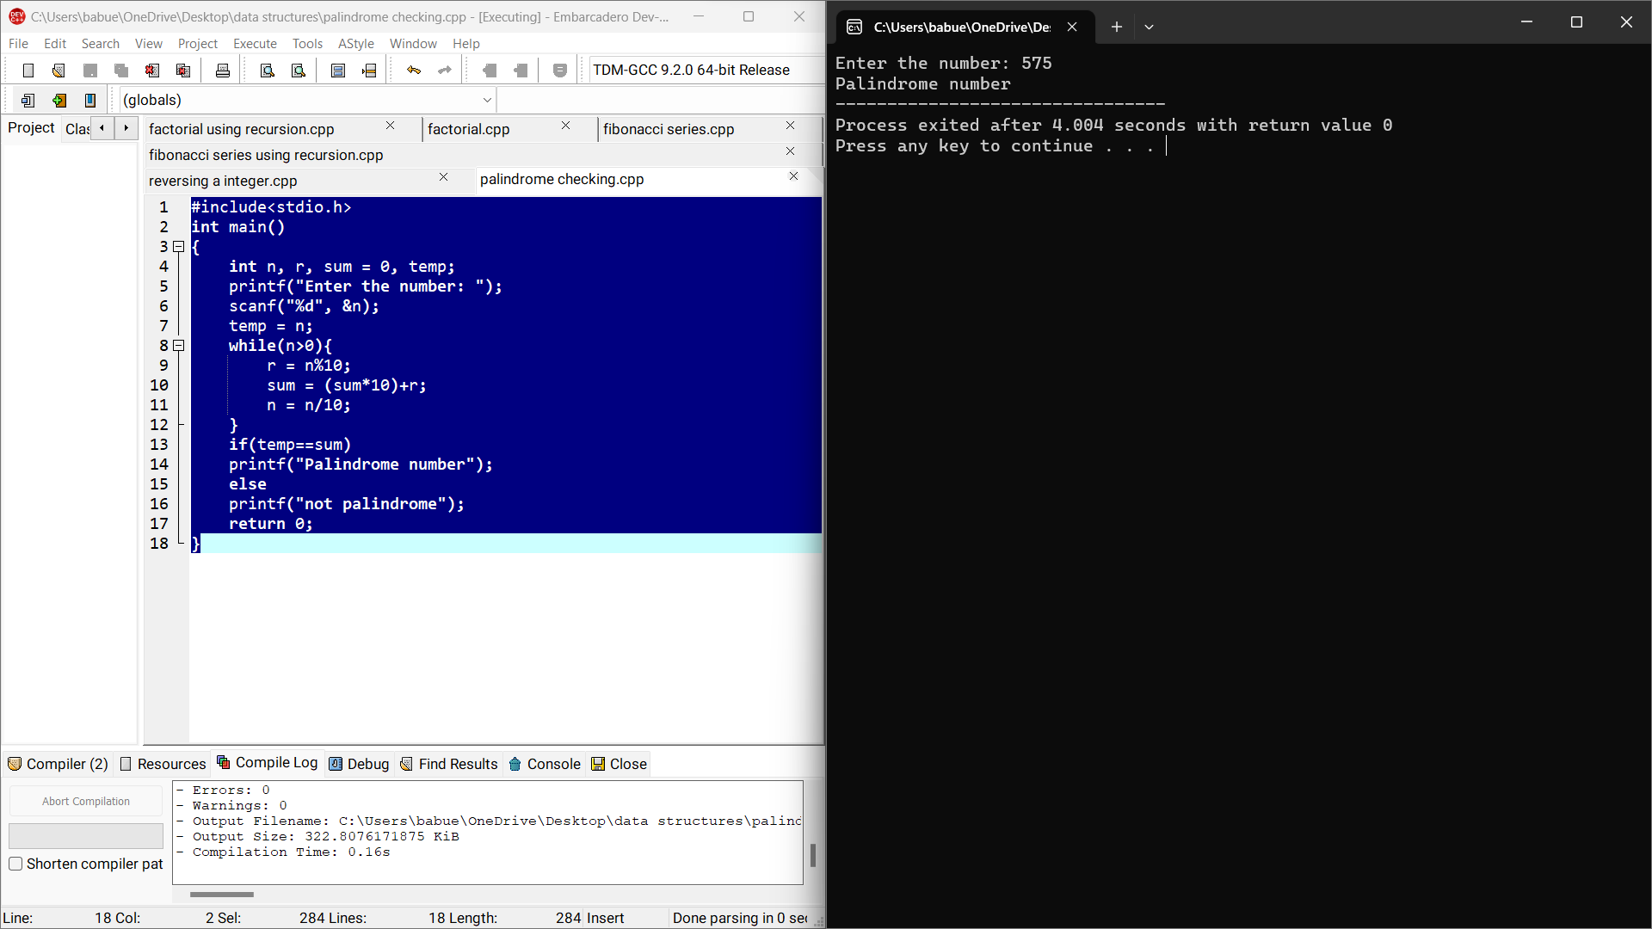

Sample input:575

Output: It is palindrome number.

11) Write a C program to check the given Armstrong or not?

Code:

#include<stdio.h>

int main()

{

int num, originalnum, rem, res=0;

printf("Enter a three digit number: ");

scanf("%d", &num);

originalnum = num;

while(originalnum != 0){

rem = originalnum % 10;

res += rem * rem * rem;

originalnum /= 10;

}

if(res == num)

printf("%d is an armstrong number", num);

else

printf("%d is not an armstrong number", num);

return 0;

}

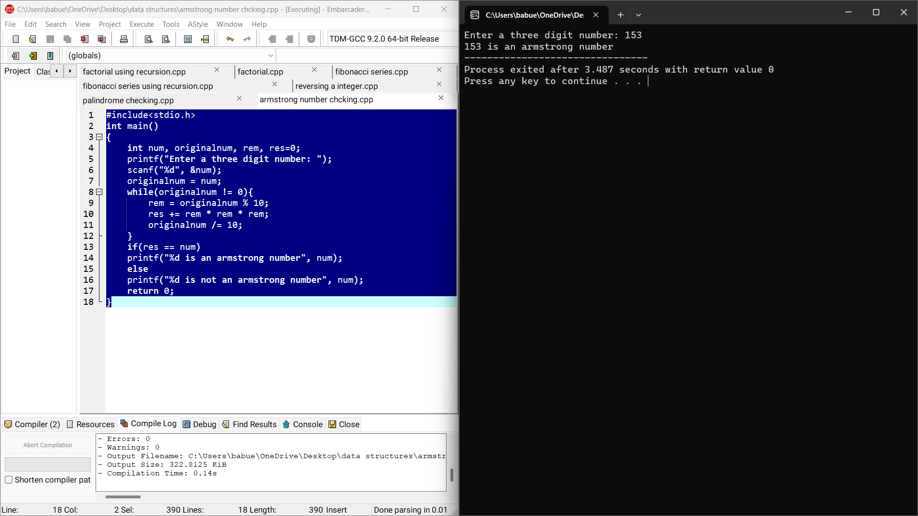

Sample input: 153

Output: It is Armstrong number.

Day 2: DATA STRUCTURES PROGRAMS

1. Write a C program to intialise the array Dynamically and print the array.

Code:

#include<stdio.h>

int main(){

int n;

printf("enter the size of array:");

scanf("%d",&n);

printf("Enter the elements:");

int a[n];

for(int i=0;i<n;i++){

scanf("%d",&a[i]);

}

for(int i=0;i<n;i++){

printf("%d ",a[i]);

}

return 0;

}

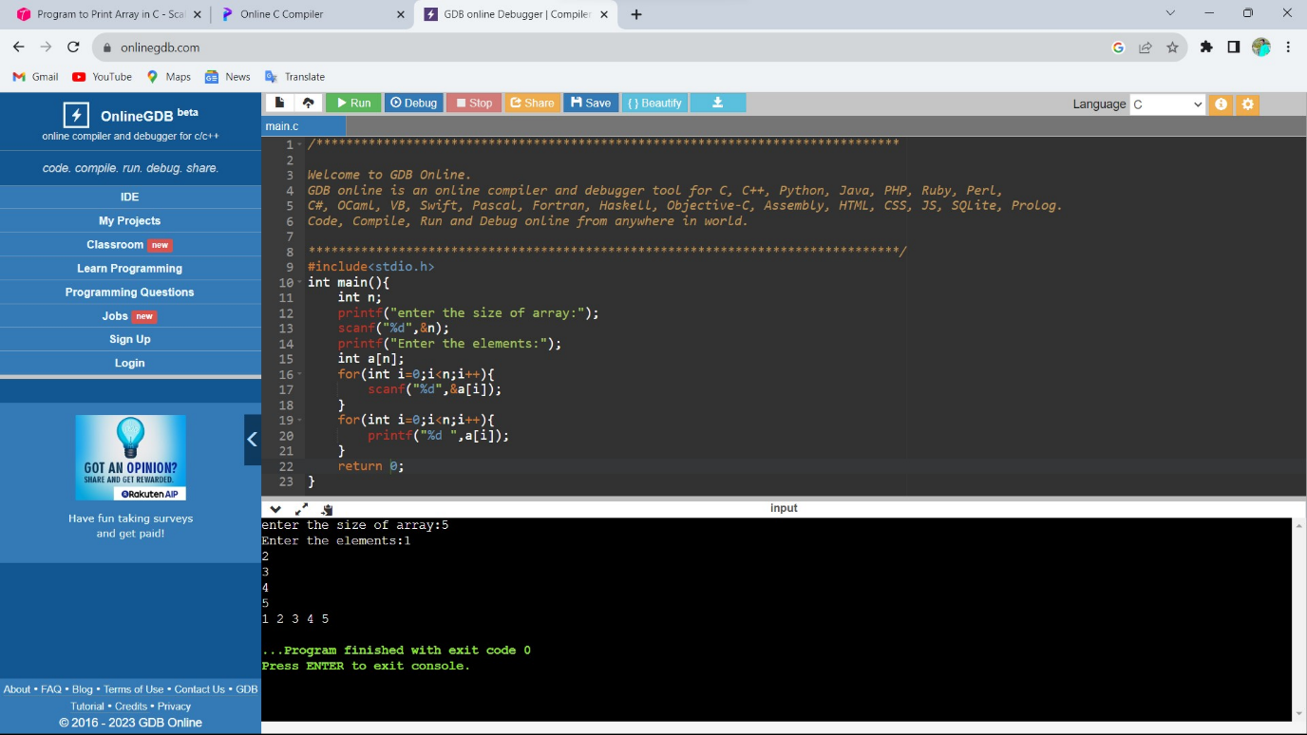

Sample input: 5 Output:1,2,3,4,5

2. Write a C program to find sum of elements in a given array.

Code:

#include<stdio.h>

int main(){

int size;

printf("Enter the size of the array: ");

scanf("%d", &size);

int arr[size];

printf("Enter the elements of the array: ");

for(int i = 0; i<size; i++){

scanf("%d", &arr[i]);

}

int sum = 0;

for(int i = 0; i < size; i++){

sum += arr[i];}

printf("sum of array elemnts : %d\n", sum);

return 0;

}

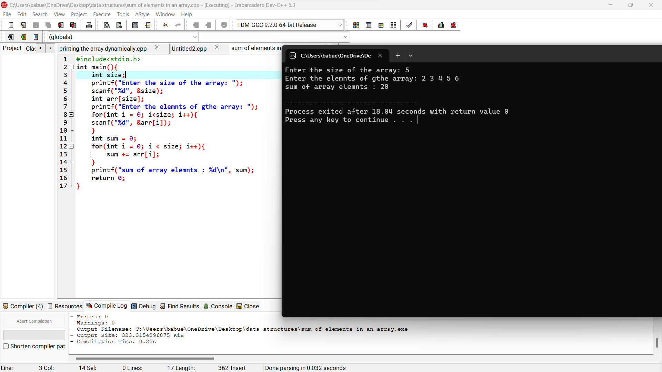

Sample input: 1,2,3,4,5 Output: 15

3. Write a c program to find sum of even and sum of odd numbers in the given array.

Code:

#include<stdio.h>

int main()

{

int size;

printf("Enter the size of the array: ");

scanf("%d", &size);

int arr[size];

printf("Enter the elements of the array: ");

for(int i = 0; i< size; i++)

{

scanf("%d", &arr[i]);

}

int sum_even = 0, sum_odd = 0;

for(int i = 0; i< size; i++)

{

if(arr[i]%2==0)

{

sum_even += arr[i];

}

else{

sum_odd += arr[i];

}

}

printf("Sum of evevn numbers: %d\n", sum_even);

printf("Sum of odd numbers: %d\n", sum_odd);

return 0;

}

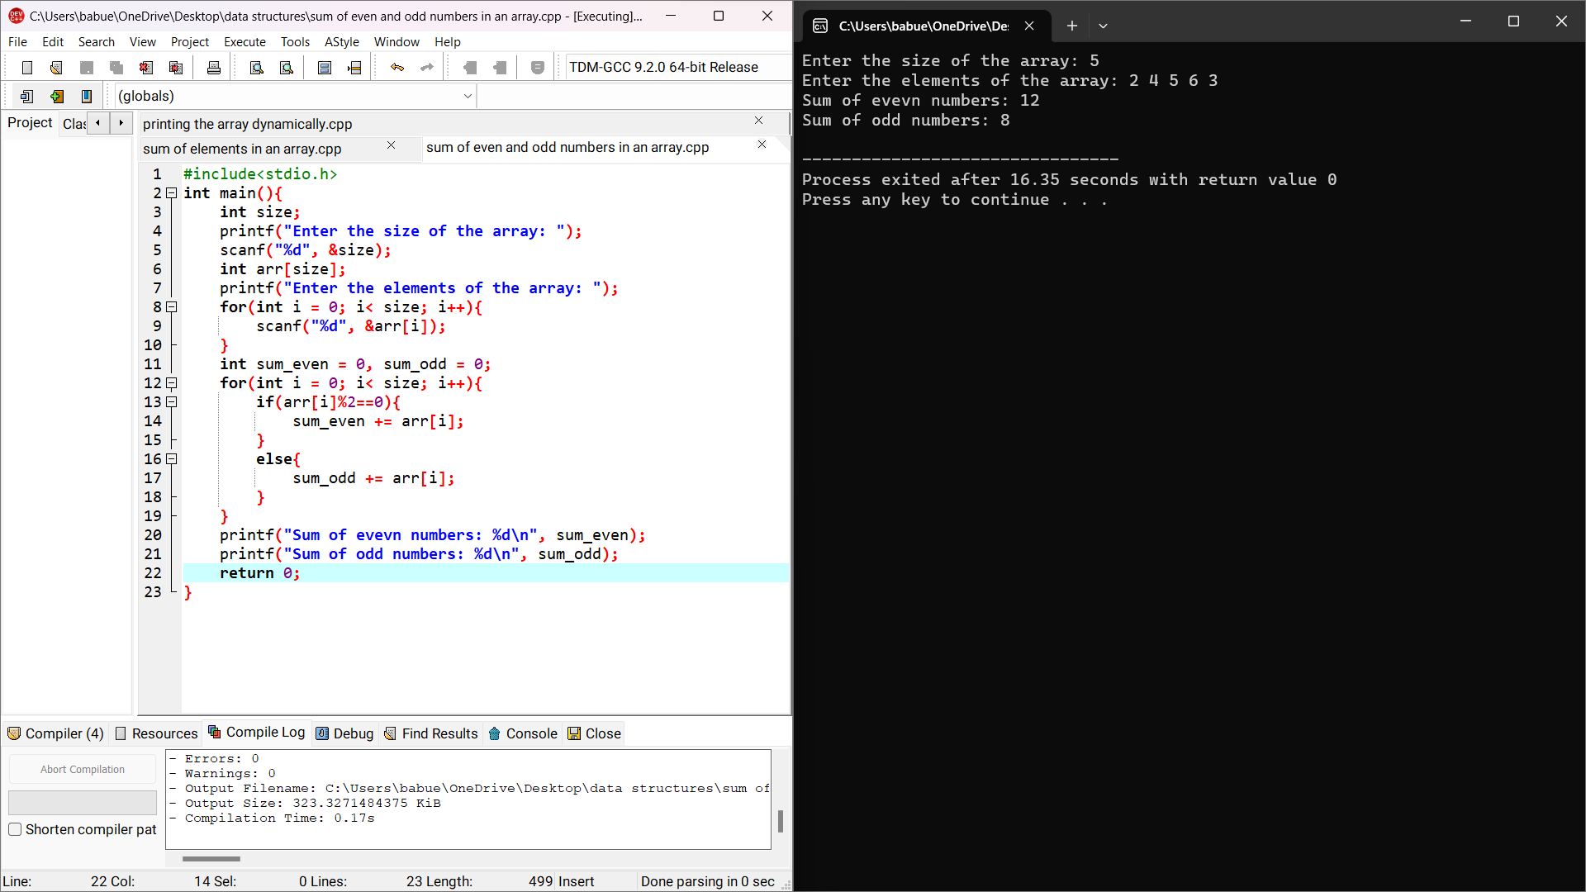

Sample input:

Size of array: 5

Array elements:5

6

8

3

1

Output:

Even sum = 14

Odd sum = 9

4. Write a c program to perform the following operations.

A.Insert an element in an array.

Code:

#include<stdio.h>

int main(){

int n,k,p,i;

printf("enter the size of array:");

scanf("%d",&n);

printf("Enter the elements:");

int a[n];

for(int i=0;i<n;i++){

scanf("%d",&a[i]);

}

printf("Enter the element to insert:");

scanf("%d",&k);

printf("Enter the element position to insert:");

scanf("%d",&p);

for(i=n;i>=p;i--){

a[i]=a[i-1];

}

a[p]=k;

n++;

for(int i=0;i<n;i++){

printf("%d ",a[i]);

}

return 0;

}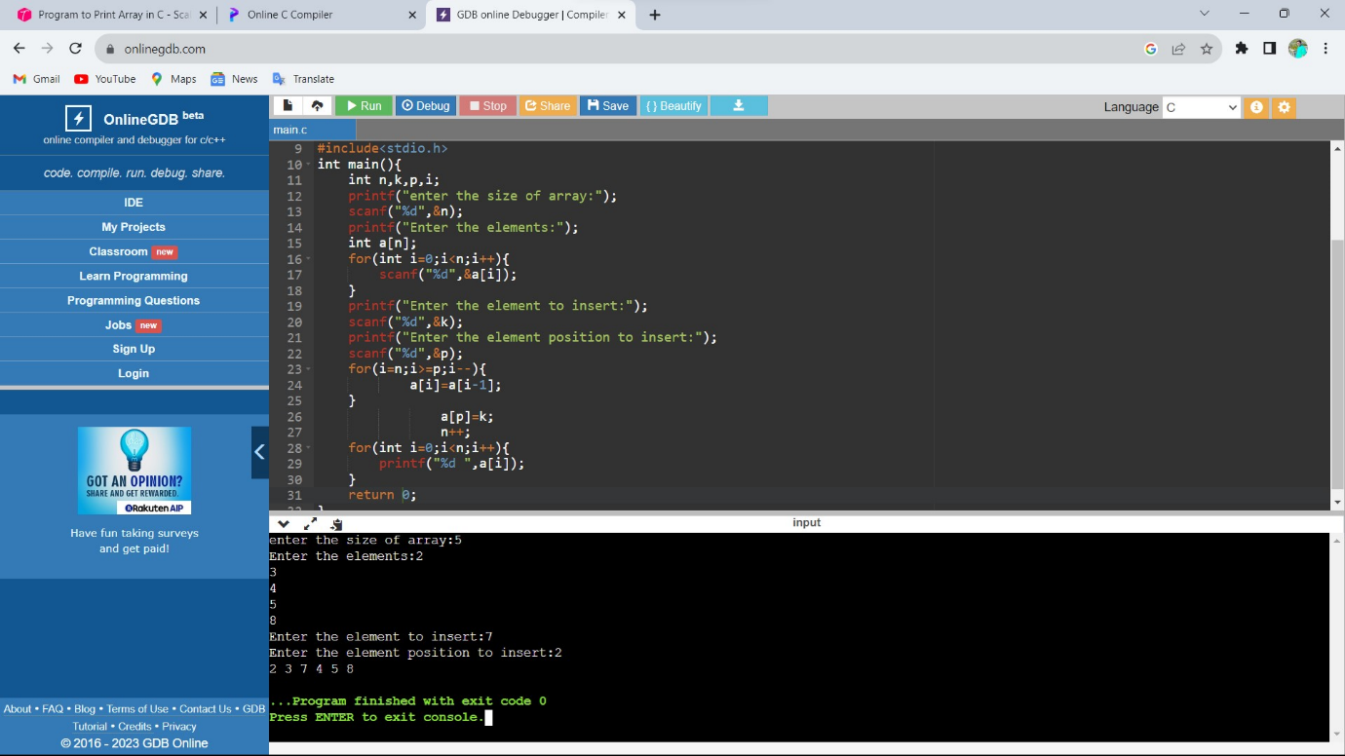

Sample input: size=5,elements=1,2,3,4,5 ;insert element=6 ; position = 2

Output: 1 2 6 3 4 5

B.Delete an element

Code:

#include<stdio.h>

int main(){

int n,k,p,i;

printf("enter the size of array:");

scanf("%d",&n);

printf("Enter the elements:");

int a[n];

for(int i=0;i<n;i++){

scanf("%d",&a[i]);

}

printf("Enter the element position to delete:");

scanf("%d",&p);

for(i=0;i<n;i++){

if(i==p){

for(int j=i;j<n;j++)

a[j]=a[j+1];

}

}

for(int i=0;i<n-1;i++){

printf("%d ",a[i]);

}

return 0;

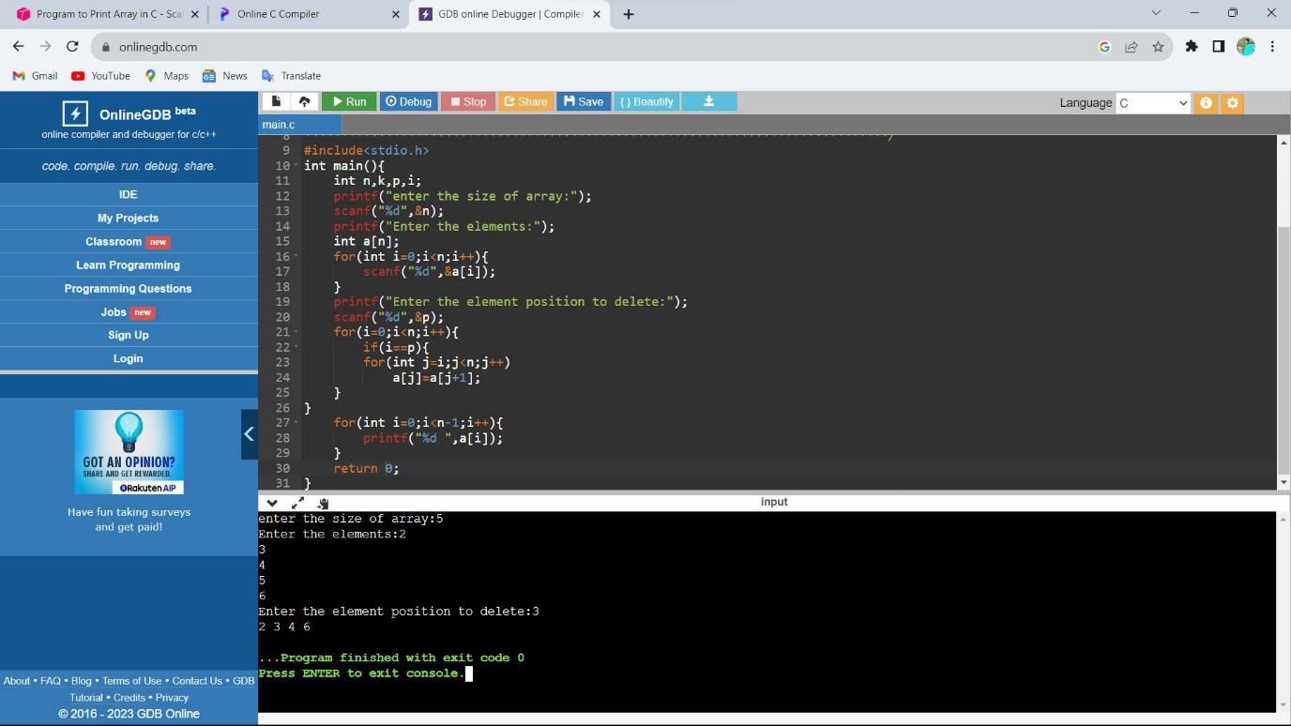

Sample input:

Size = 5

Elements = 1 2 3 4 5

Position to delete =4

Output: 1 2 3 4

5. Write a c program to merge two arrays.

Code:

#include<stdio.h>

int main(){

int n,m,i,j,o=0;

printf("enter the size of array 1:");

scanf("%d",&n);

printf("Enter the elements:");

int a[n];

for(i=0;i<n;i++){

scanf("%d",&a[i]);

}

printf("enter the size of array 2:");

scanf("%d",&m);

printf("Enter the elements:");

int b[m],k[m+n];

for(j=0;j<m;j++){

scanf("%d",&b[j]);

}

for(i=0;i<n;i++){

k[i]=a[i];

}

j=i;

for(i=0;i<m;i++){

k[j]=b[i];

j++;

}

for(int i=0;i<m+n;i++){

printf("%d ",k[i]);

}

return 0;

}

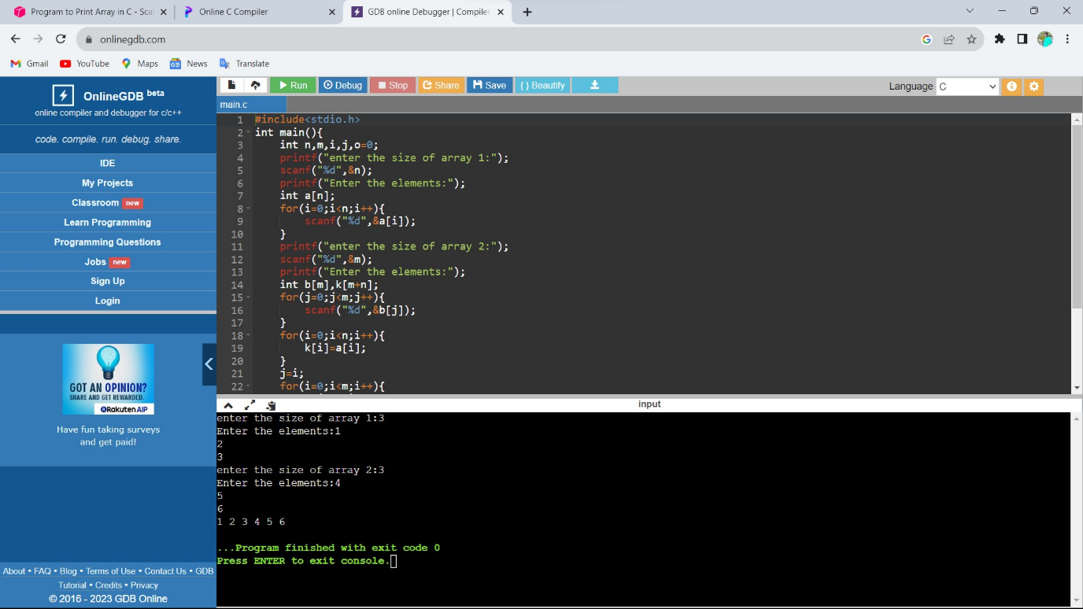

Sample input: size of array 1=3

Elements=1 2 3

Size of array 2=3

Elements= 4 5 6

Output: 1 2 3 4 5 6

6. Write a c program to find duplicate value in array.

Code:

#include <stdio.h>

#define MAX_SIZE 100

int main()

{

int arr[MAX_SIZE];

int i, j, size, count = 0;

printf("Enter size of the array : ");

scanf("%d", &size);

printf("Enter elements in array : ");

for(i=0; i<size; i++)

{

scanf("%d", &arr[i]);

}

for(i=0; i<size; i++)

{

for(j=i+1; j<size; j++)

{

if(arr[i] == arr[j])

{

count++;

break;

}

}

}

printf("\nTotal number of duplicate elements found in array = %d", count);

return 0;

}

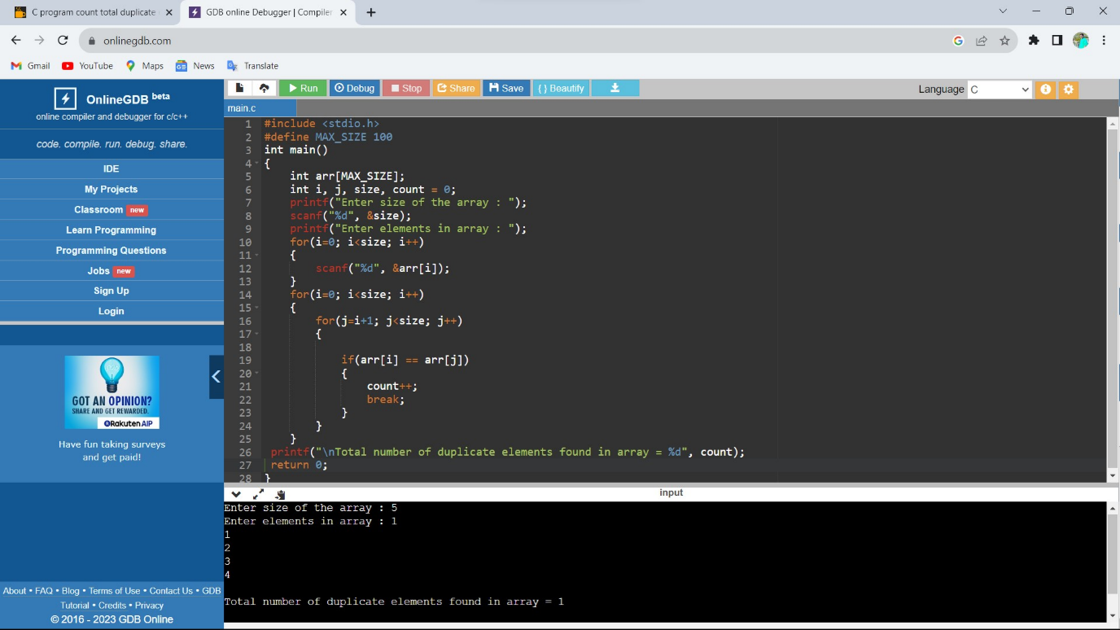

Sample input:

Array elements : 1 2 3 4 5 6 1

Output: 1

7. Write a C program to find greatest element among array elements.

Code:

#include <stdio.h>

int main() {

int n;

double arr[100];

printf("Enter the number of elements (1 to 100): ");

scanf("%d", &n);

for (int i = 0; i < n; ++i) {

printf("Enter number%d: ", i + 1);

scanf("%lf", &arr[i]);

}

for (int i = 1; i < n; ++i) {

if (arr[0] < arr[i]) {

arr[0] = arr[i];

}

}

printf("Largest element = %.2lf", arr[0]);

return 0;

}

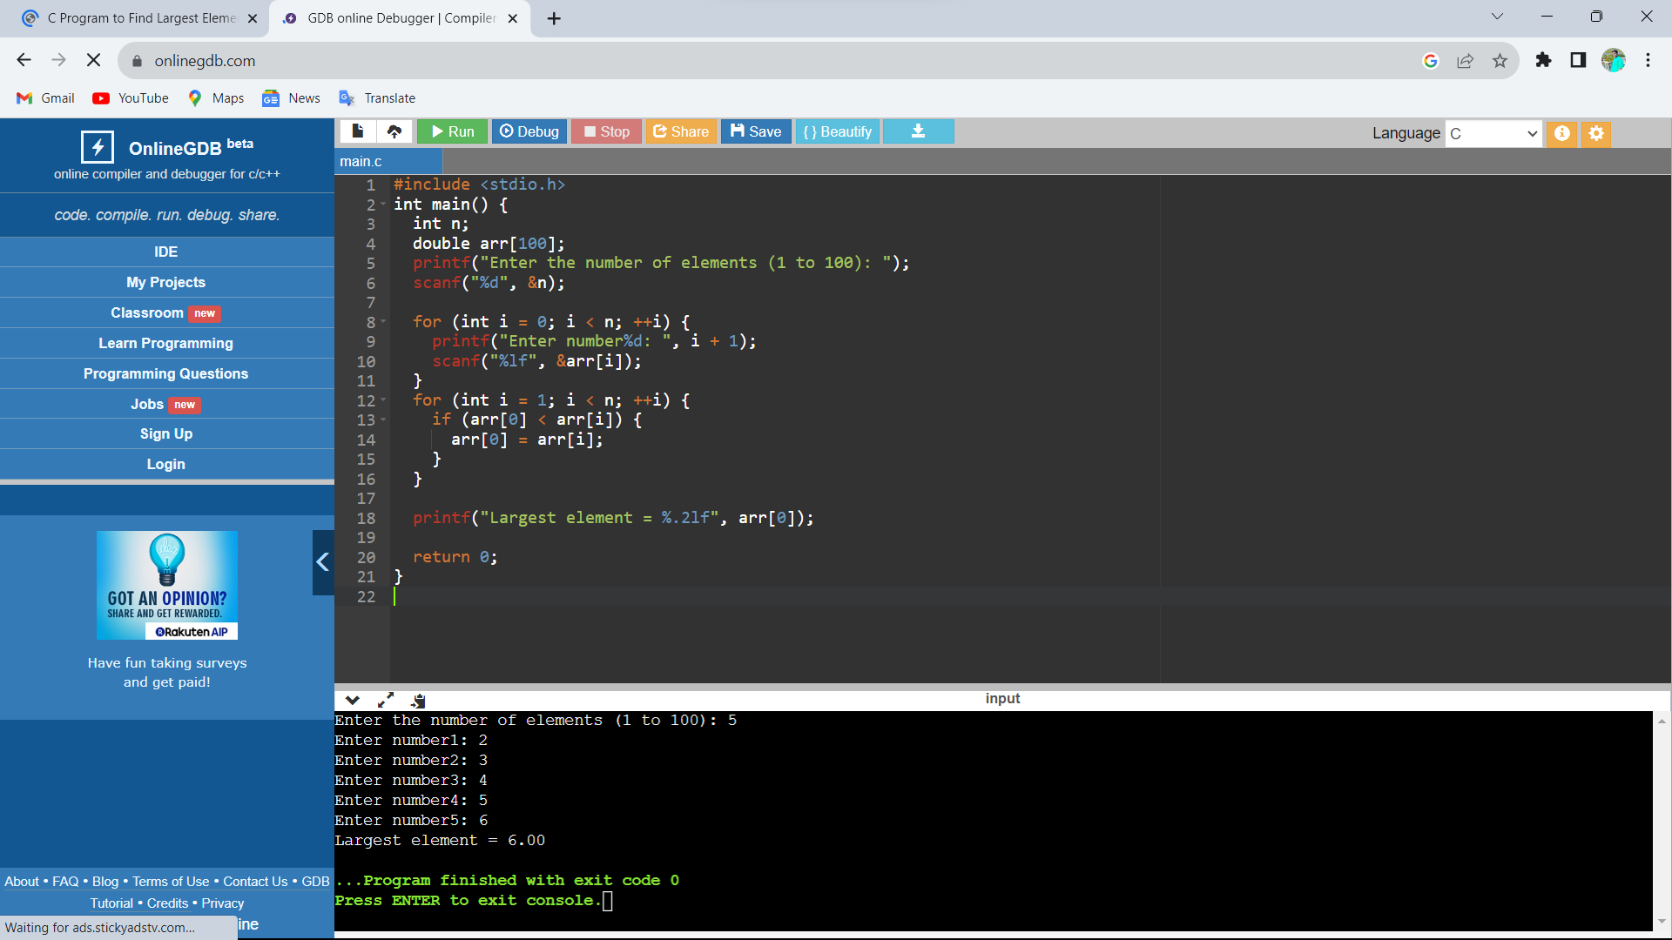

Sample input: 2 3 4 5 6

Output: 6

8. Write a C program to search an element in array using linear search.

Code:

#include <stdio.h>

int main()

{

int array[100], search, c, number;

printf("Enter the number of elements in array\n");

scanf("%d",&number);

printf("Enter %d numbers\n", number);

for ( c = 0 ; c < number ; c++ )

scanf("%d",&array[c]);

printf("Enter the number to search\n");

scanf("%d",&search);

for ( c = 0 ; c < number ; c++ )

{

if ( array[c] == search )

{

printf("%d is present at location %d.\n", search, c+1);

break;

}

}

if ( c == number )

printf("%d is not present in array.\n", search);

return 0;

}

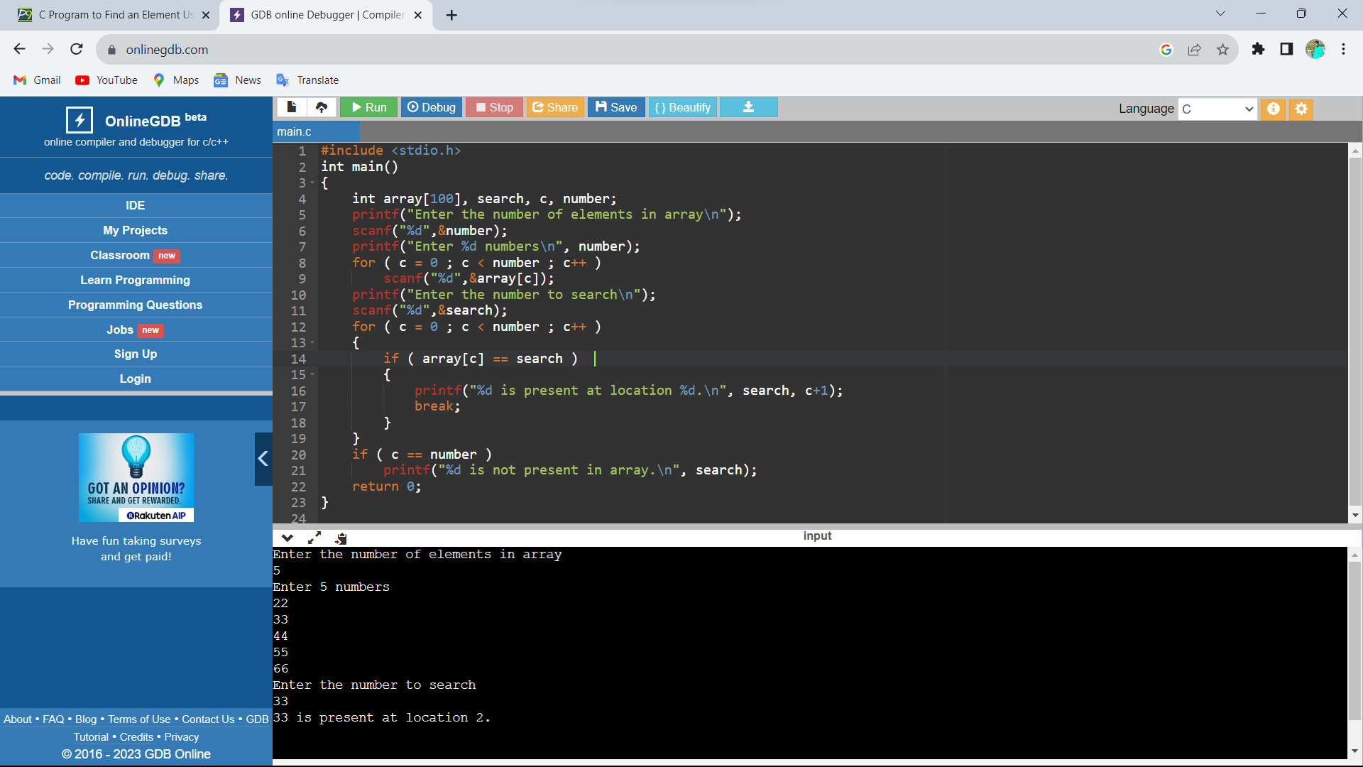

Sample input:

Number of elements: 5

Enter the elements:22 33 44 55 66

Number to search: 33

Output: 33 is present at location 1 .

9. Write a c program to search an element in array using binary search.

Code:

//Program Name: BinarySearch.c #include<stdio.h>

int main()

{

int c, first, last, middle, n, search, array[100];

printf("Enter number of elements\n");

scanf("%d",&n);

printf("Enter %d integers\n", n);

for ( c = 0 ; c < n ; c++ )

scanf("%d",&array[c]);

printf("Enter value to find\n");

scanf("%d",&search);

first = 0;

last = n - 1;

middle = (first+last)/2;

while( first <= last )

{

if ( array[middle] < search )

first = middle + 1;

else if ( array[middle] == search )

{

printf("%d found at location %d.\n", search, middle+1);

break;

}

else

last = middle - 1;

middle = (first + last)/2;

}

if ( first > last )

printf("Not found! %d is not present in the list.\n", search);

return 0;

}

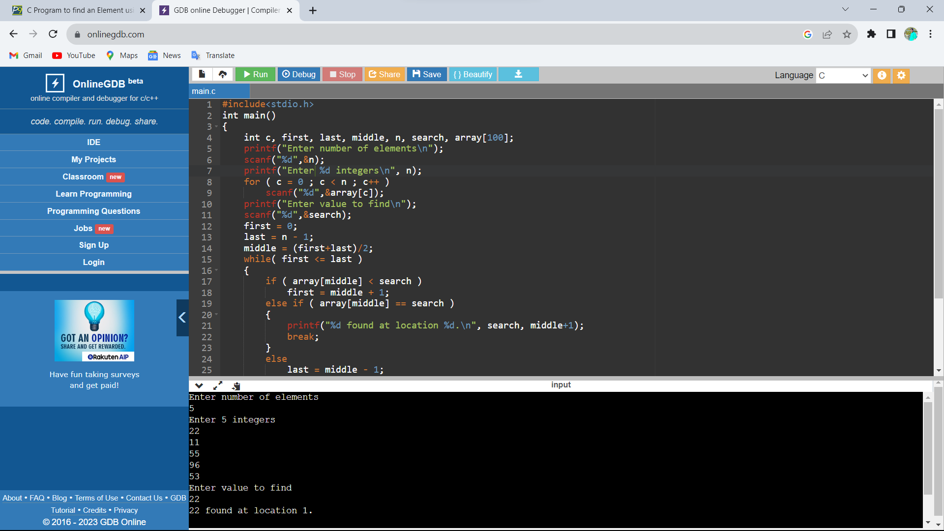

Sample input:

Number of elements: 5

Elements: 22 11 55 96 53

Value to find: 22

Output: 22 is found at location 1.

10. Write a C program to reverse a string.

Code:

#include <stdio.h>

#include <string.h>

int main(){

char s[100];

printf("Enter a string to reverse\n");

gets(s);

strrev(s);

printf("Reverse of the string: %s\n", s);

return 0;

}

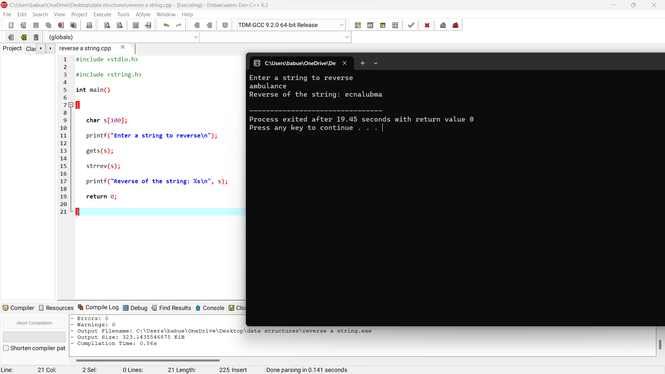

Sample input: ambulance

Output: ecnalubma

11. Write a C program to check the string palindrome or not.

Code:

#include <stdio.h>

#include <string.h>

int main(){

char s[1000];

int i,n,c=0;

printf("Enter the string : ");

gets(s);

n=strlen(s);

for(i=0;i<n/2;i++) {

if(s[i]==s[n-i-1])

c++;}

if(c==i)

printf("string is palindrome");

else

printf("string is not palindrome");

return 0;}

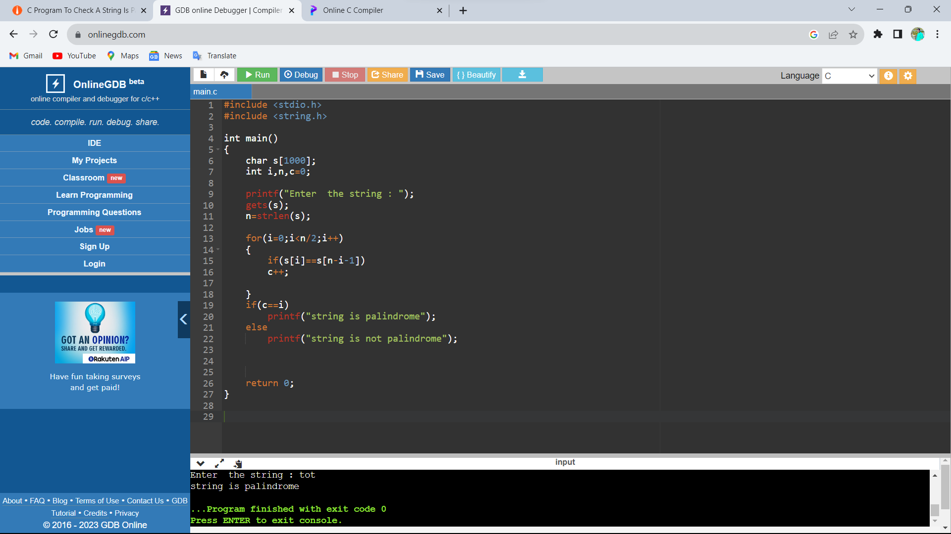

Sample input: tot , malayalam Output: palindrome

12. Write a C program to count no.of vowels in a string .

Code:

#include <stdio.h>

#include <ctype.h>

int main(){

char str[100];

int i, vowels = 0;

printf("Enter the string: ");

scanf("%[^\n]s",&str);

for(i = 0; str[i]; i++) {

if(str[i]=='a'|| str[i]=='e'||str[i]=='i'||

str[i]=='o'|| str[i]=='u'||str[i]=='A'||

str[i]=='E'||str[i]=='I'||str[i]=='O' ||str[i]=='U') {

vowels++;

}

}

printf("Total number of vowels: = %d\n",vowels);

return 0;}

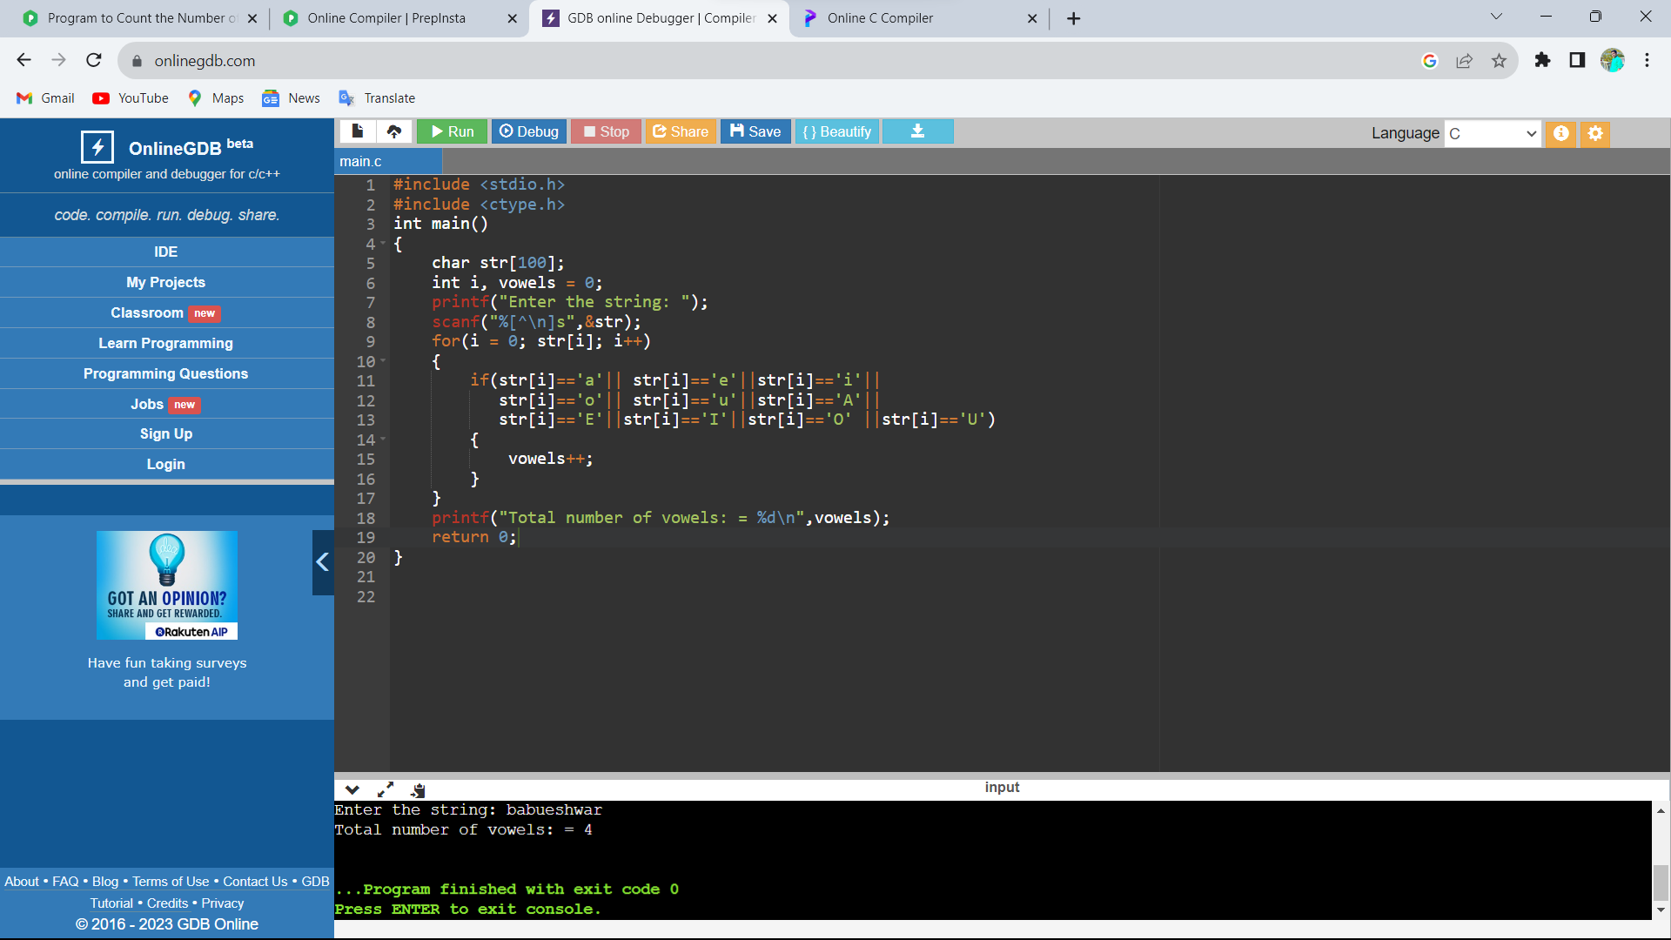

Sample input: saikumar Output: 4

13. Write a C program to find matrix Multiplication.

Code:

#include<stdio.h>

int main() {

int a[10][10], b[10][10], c[10][10], n, i, j, k;

printf("Enter the value of N (N <= 10): ");

scanf("%d", & n);

printf("Enter the elements of Matrix-A: \n");

for (i = 0; i < n; i++) {

for (j = 0; j < n; j++) {

scanf("%d", & a[i][j]);

}

}

printf("Enter the elements of Matrix-B: \n");

for (i = 0; i < n; i++) {

for (j = 0; j < n; j++) {

scanf("%d", & b[i][j]);

}

}

for (i = 0; i < n; i++) {

for (j = 0; j < n; j++) {

c[i][j] = 0;

for (k = 0; k < n; k++) {

c[i][j] += a[i][k] * b[k][j];

}

}

}

printf("The product of the two matrices is: \n");

for (i = 0; i < n; i++) {

for (j = 0; j < n; j++) {

printf("%d\t", c[i][j]);

}

printf("\n");

}

return 0;

}

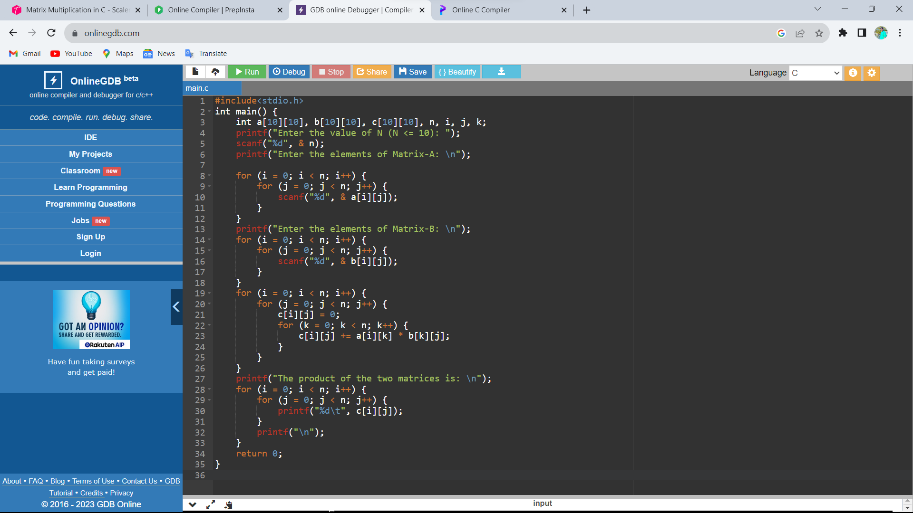

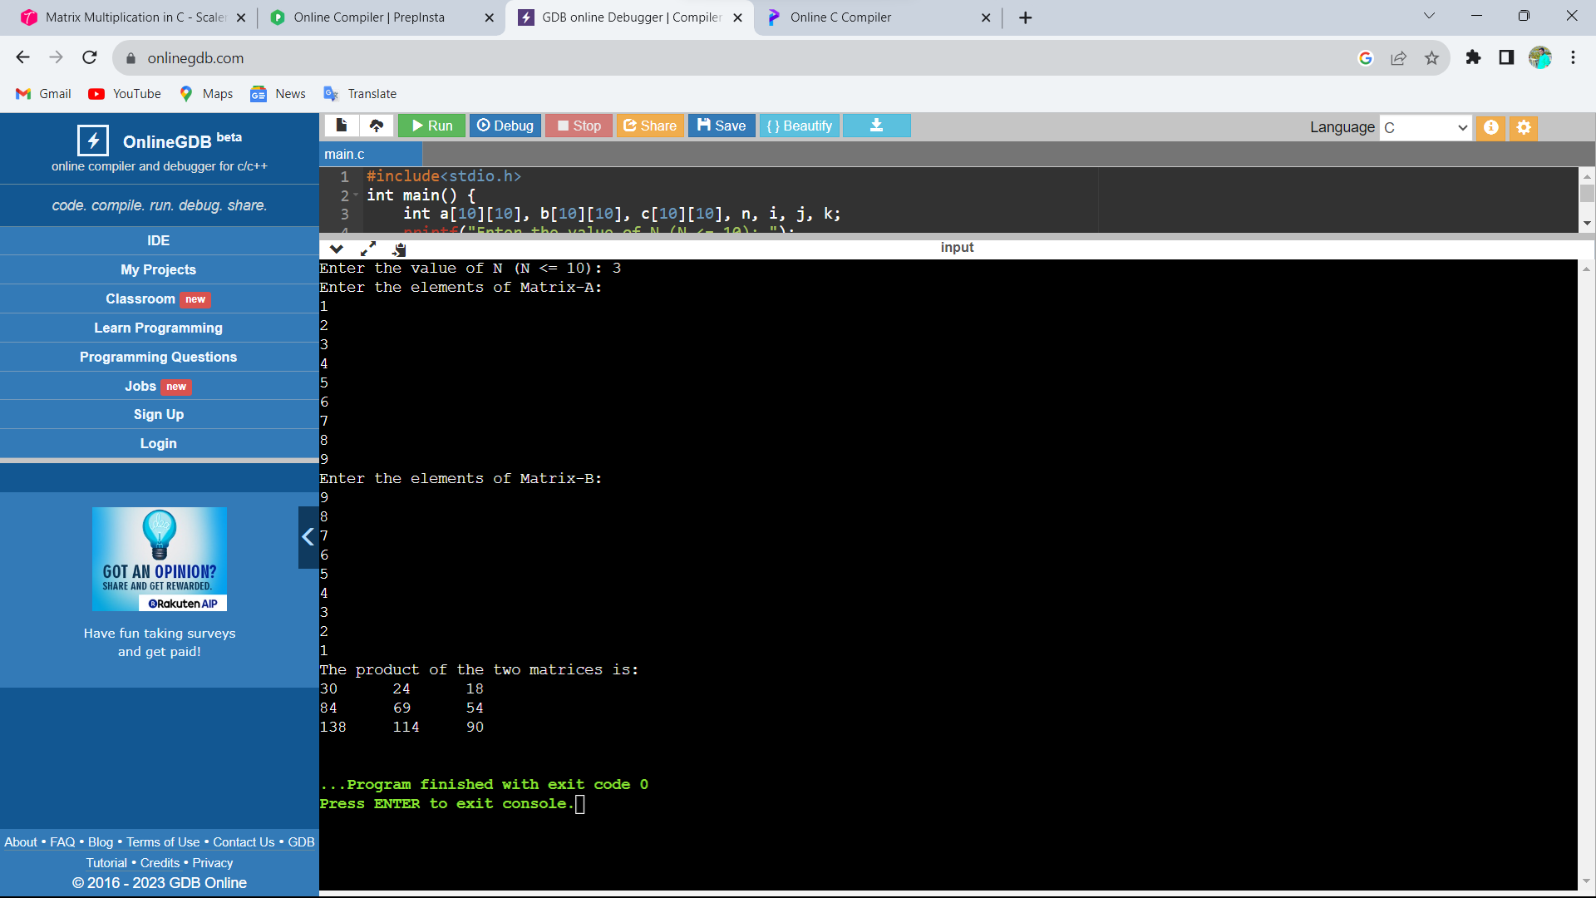

Sample input:

Elements of matrix A: 1 2 3 4 5 6 7 8 9

Elements of matrix B: 9 8 7 6 5 4 3 2 1

Output:

Product of two matrices is:

30 24 18

84 69 54

138 114 90

Day 3: DATA STRUCTURES PROGRAMS

1.write a c program to implement linked list data structure.

Program:

#include <stdlib.h>

struct Node {

int data; #include <stdio.h>

struct Node* next;

};

void insert(struct Node** head, int value) {

struct Node* newNode = (struct Node*)malloc(sizeof(struct Node));

newNode->data = value;

newNode->next = NULL;

if (*head == NULL) {

*head = newNode;

} else {

struct Node* current = *head;

while (current->next != NULL) {

current = current->next;

}

current->next = newNode;

}

}

void deleteElement(struct Node** head, int value) {

if (*head == NULL) {

printf("List is empty.\n");

return;

}

struct Node* current = *head;

struct Node* previous = NULL;

while (current != NULL && current->data != value) {

previous = current;

current = current->next;

}

if (current == NULL) {

printf("Element not found in the list.\n");

return;

}

if (previous == NULL) {

*head = current->next;

} else {

previous->next = current->next;

}

free(current);

printf("Element deleted successfully.\n");

}

void display(struct Node* head) {

struct Node* current = head;

while (current != NULL) {

printf("%d ", current->data);

current = current->next;

}

printf("\n");

}

int main() {

struct Node* head = NULL;

int choice, value;

while (1) {

printf("1. Insert an element\n");

printf("2. Delete an element\n");

printf("3. Display the list\n");

printf("4. Exit\n");

printf("Enter your choice: ");

scanf("%d", &choice);

switch (choice) {

case 1:

printf("Enter the value to insert: ");

scanf("%d", &value);

insert(&head, value);

break;

case 2:

printf("Enter the value to delete: ");

scanf("%d", &value);

deleteElement(&head, value);

break;

case 3:

display(head);

break;

case 4:

exit(0);

default:

printf("Invalid choice. Please try again.\n");}}

return 0;

}

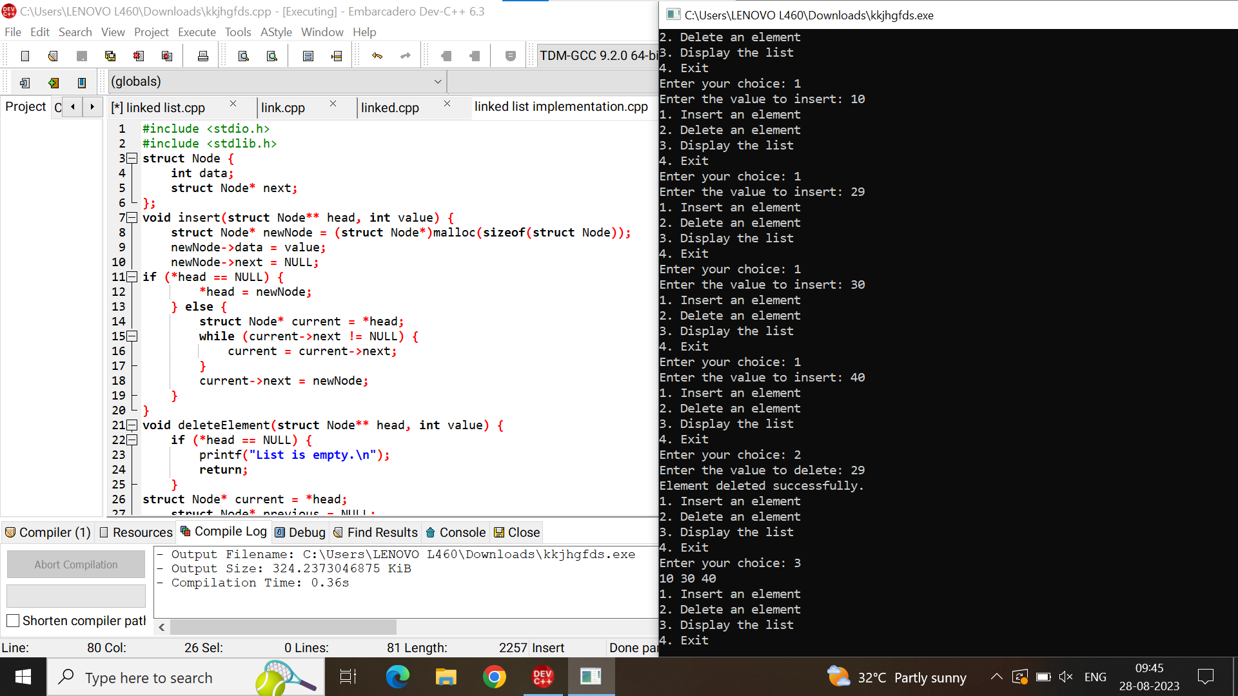

Sample input: enter the choice:1

Enter the value to insert:10

29

30

40

Enter the choice:2

Enter the value to delete:29

Output: display the list : 10

30

40

2.write a c program to merge two list.

Program:

#include <stdio.h>

#include <stdlib.h>

struct Node {

int data;

struct Node* next;

};

struct Node* createNode(int data) {

struct Node* newNode = (struct Node*)malloc(sizeof(struct Node));

newNode->data = data;

newNode->next = NULL;

return newNode;

}

void insertEnd(struct Node** head, int data) {

struct Node* newNode = createNode(data);

if (*head == NULL) {

*head = newNode;

} else {

struct Node* temp = *head;

while (temp->next != NULL) {

temp = temp->next;

}

temp->next = newNode;

}

}

struct Node* mergeLists(struct Node* list1, struct Node* list2) {

if (list1 == NULL) {

return list2;

}

if (list2 == NULL) {

return list1;

}

if (list1->data < list2->data) {

list1->next = mergeLists(list1->next, list2);

return list1;

} else {

list2->next = mergeLists(list1, list2->next);

return list2;

}

}

void displayList(struct Node* head) {

struct Node* temp = head;

while (temp != NULL) {

printf("%d -> ", temp->data);

temp = temp->next;

}

printf("NULL\n");

}

int main() {

struct Node* list1 = NULL;

struct Node* list2 = NULL;

int n, m;

printf("Enter the size of list 1: ");

scanf("%d", &n);

printf("Enter the elements of list 1:\n");

for (int i = 0; i < n; i++) {

int num;

scanf("%d", &num);

insertEnd(&list1, num);

}

printf("Enter the size of list 2: ");

scanf("%d", &m);

printf("Enter the elements of list 2:\n");

for (int i = 0; i < m; i++) {

int num;

scanf("%d", &num);

insertEnd(&list2, num);

}

printf("List 1: ");

displayList(list1);

printf("List 2: ");

displayList(list2);

struct Node* mergedList = mergeLists(list1, list2);

printf("Merged List: ");

displayList(mergedList);

return 0;

}

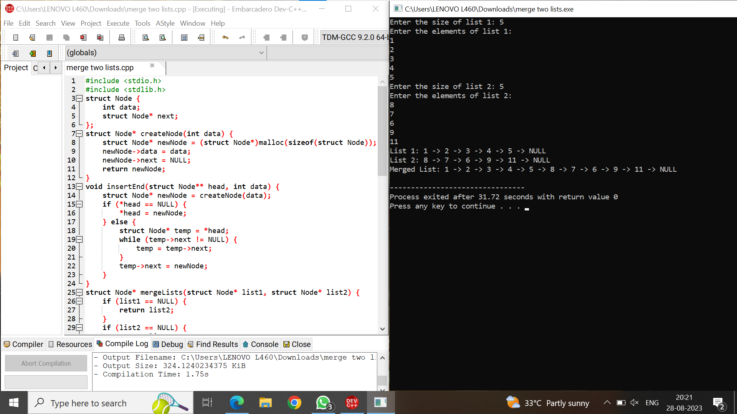Sample input: size of list1:5 = 1 2 3 4 5 , list2: 5 = 8 7 6 9 11

Output: 1=> 2=> 3=> 4=> 5=> 8=> 7=> 6=> 9=> 11=> null.

3.write a c program to implement stack operstions.

Program:

#include <stdio.h>

#include <stdlib.h>

#define SIZE 4

int top = -1, inp_array[SIZE];

void push();

void pop();

void show();

int main()

{

int choice;

while (1)

{

printf("\nPerform operations on the stack:");

printf("\n1.Push the element\n2.Pop the element\n3.Show\n4.End");

printf("\n\nEnter the choice: ");

scanf("%d", &choice);

switch (choice)

{

case 1:

push();

break;

case 2:

pop();

break;

case 3:

show();

break;

case 4:

exit(0);

default:

printf("\nInvalid choice!!");

}

}

}

void push()

{

int x;

if (top == SIZE - 1)

{

printf("\nOverflow!!");

}

else

{

printf("\nEnter the element to be added onto the stack: ");

scanf("%d", &x);

top = top + 1;

inp_array[top] = x;

}

}

void pop()

{

if (top == -1)

{

printf("\nUnderflow!!");

}

else

{

printf("\nPopped element: %d", inp_array[top]);

top = top - 1;

}

}

void show()

{

if (top == -1)

{

printf("\nUnderflow!!");

}

else

{

printf("\nElements present in the stack: \n");

for (int i = top; i >= 0; --i)

printf("%d\n", inp_array[i]);

}

}

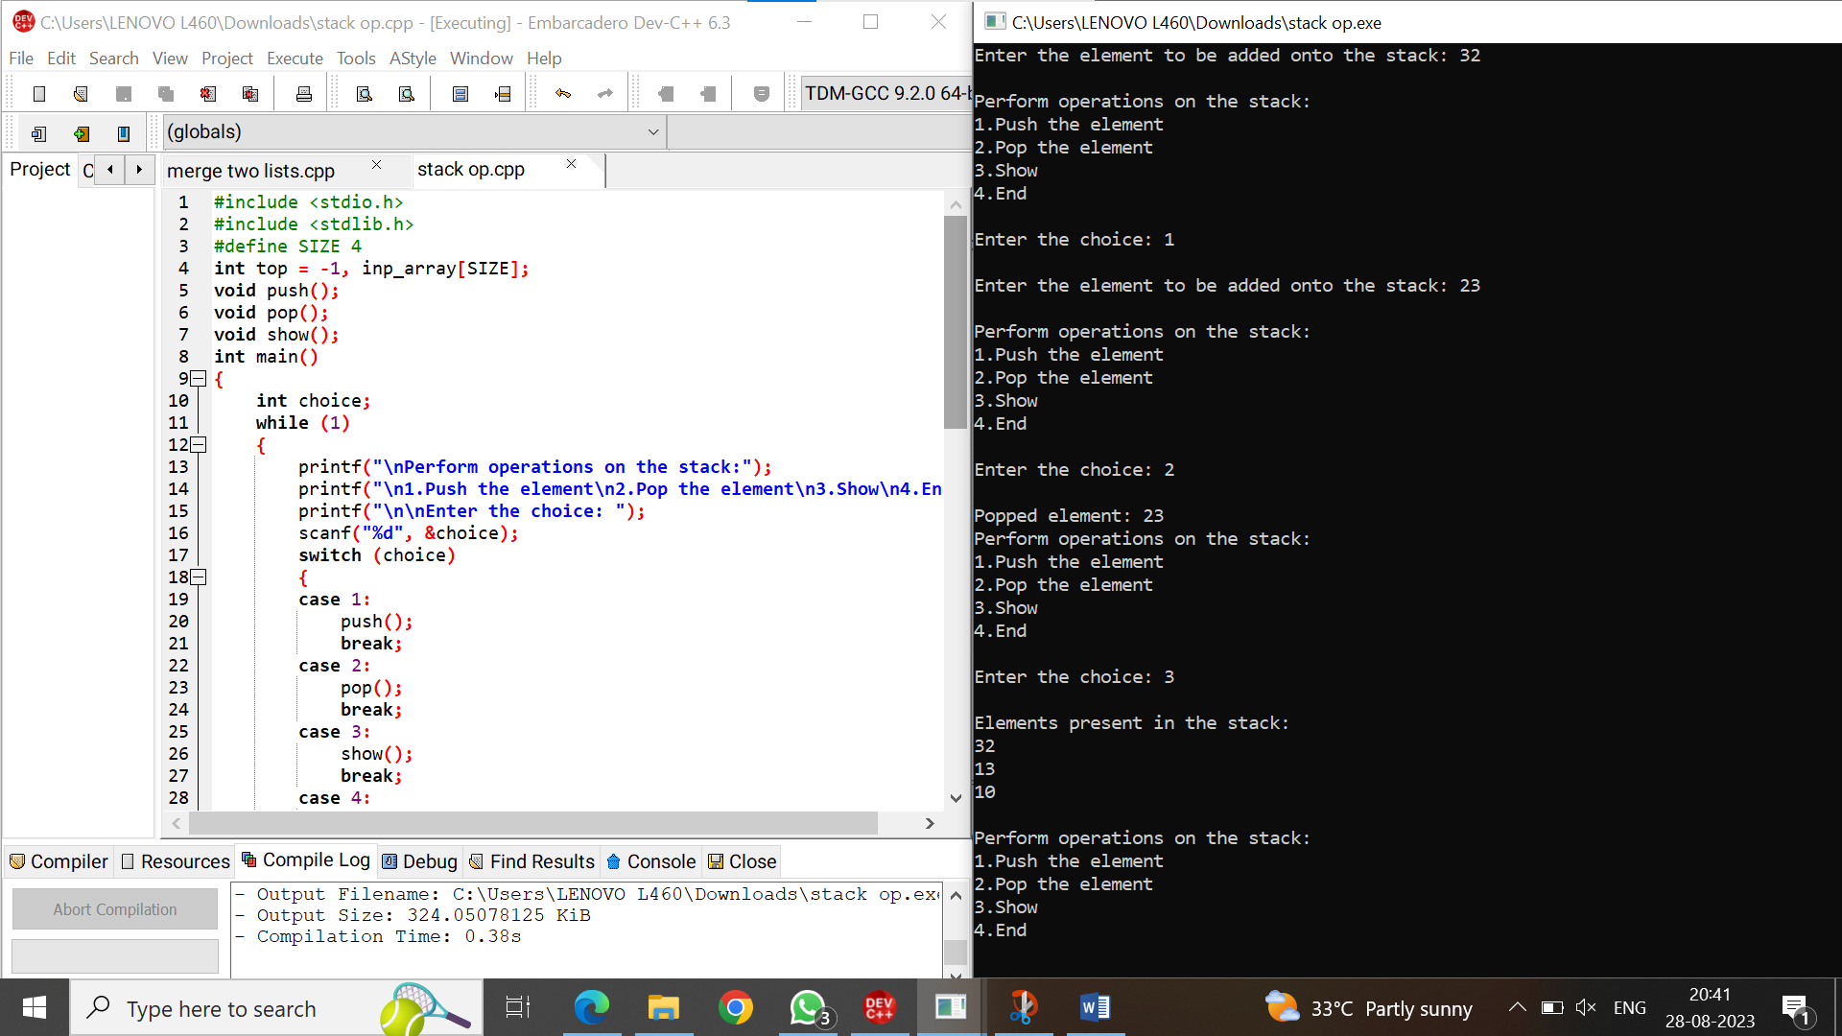

Sample input: push elements = 10,13,20,32,43 pop element 43

Output: elements present in the stack :32 , 20 , 13, 10.

4.write a c program to implement queue data structure.

Program:

#include<stdio.h>

#define n 5

int main()

{

int queue[n],ch=1,front=0,rear=0,i,j=1,x=n;

printf("Queue using Array");

printf("\n1.enqueue \n2.Dequeue \n3.Display \n4.Exit");

while(ch)

{

printf("\nEnter the Choice:");

scanf("%d",&ch);

switch(ch)

{

case 1:

if(rear==x)

printf("\n Queue is Full");

else

{

printf("\n Enter no %d:",j++);

scanf("%d",&queue[rear++]);

}

break;

case 2:

if(front==rear)

{

printf("\n Queue is empty");

}

else

{

printf("\n Deleted Element is %d",queue[front++]);

x++;

}

break;

case 3:

printf("\nQueue Elements are:\n ");

if(front==rear)

printf("\n Queue is Empty");

else

{

for(i=front; i<rear; i++)

{

printf("%d",queue[i]);

printf("\n");

}

break;

case 4:

exit(0);

default:

printf("Wrong Choice: please see the options");

}

}

}

return 0;

}

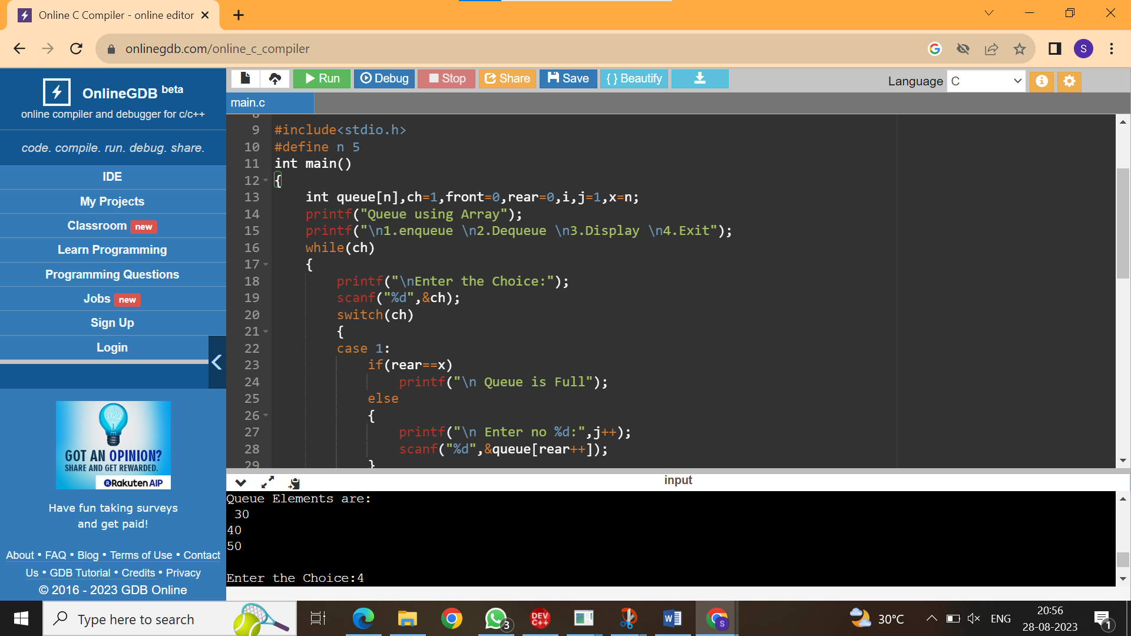

Sample input:

Enqueue elements: 10 20 30 40 50

Dequeue elements: 10 20

Output: display the elements: 30

40

50

5.write a c program to convert infix to postfix using stack.

Program:

#include<stdio.h>

#include<ctype.h>

char stack[100];

int top = -1;

void push(char x)

{

stack[++top] = x;

}

char pop()

{

if(top == -1)

return -1;

else

return stack[top--];

}

int priority(char x)

{

if(x == '(')

return 0;

if(x == '+' || x == '-')

return 1;

if(x == '*' || x == '/')

return 2;

return 0;

}

int main()

{

char exp[100];

char *e, x;

printf("Enter the expression : ");

scanf("%s",exp);

printf("\n");

e = exp;

while(*e != '\0')

{

if(isalnum(*e))

printf("%c ",*e);

else if(*e == '(')

push(*e);

else if(*e == ')')

{

while((x = pop()) != '(')

printf("%c ", x);

}

else

{

while(priority(stack[top]) >= priority(*e))

printf("%c ",pop());

push(*e);

}

e++;

}

while(top != -1)

{

printf("%c ",pop());

}

return 0;

}

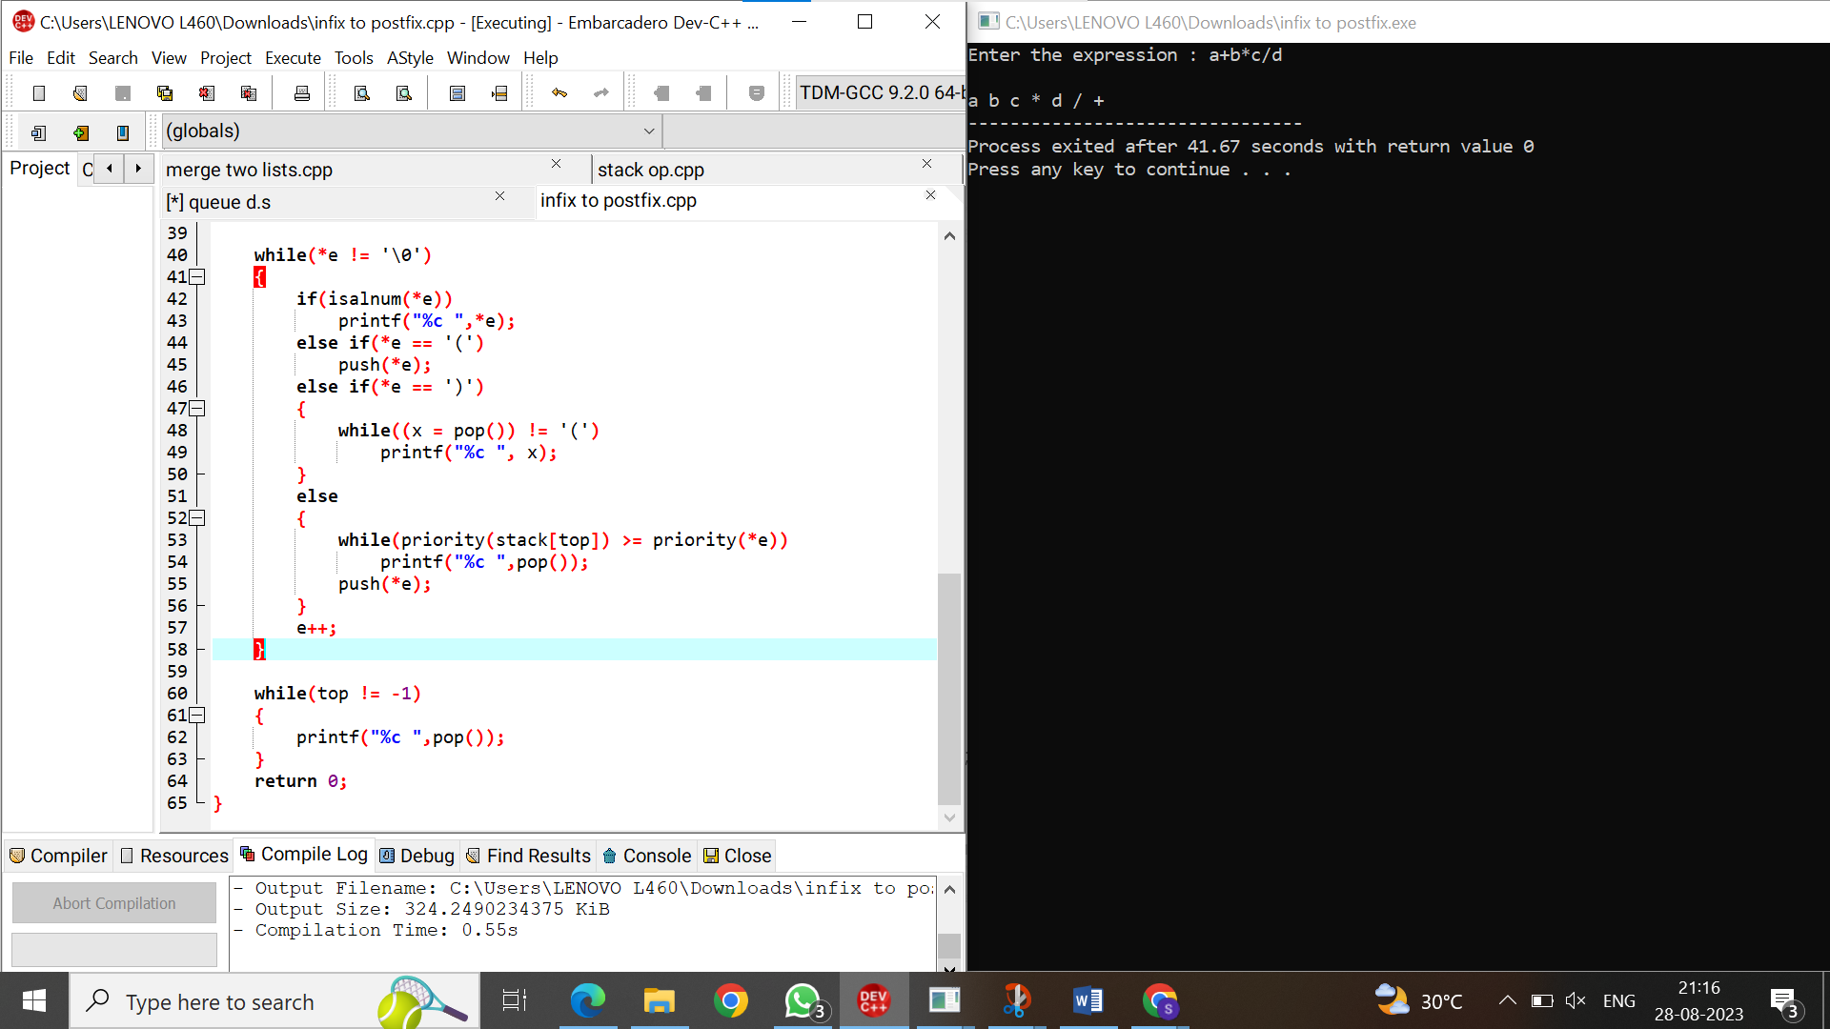

Sample input:

Expression : a+b*c/d

Output:

abc*d/+

6.write a c program to evaluate the postfix expression.

Program: #include<stdio.h>

int stack[20];

int top = -1;

void push(int x)

{

stack[++top] = x;

}

int pop()

{

return stack[top--];

}

int main()

{

char exp[20];

char *e;

int n1,n2,n3,num;

printf("Enter the expression :: ");

scanf("%s",exp);

e = exp;

while(*e != '\0')

{

if(isdigit(*e))

{

num = *e - 48;

push(num);

}

else

{

n1 = pop();

n2 = pop();

switch(*e)

{

case '+':

{

n3 = n1 + n2;

break;

}

case '-':

{

n3 = n2 - n1;

break;

}

case '*':

{

n3 = n1 * n2;

break;

}

case '/':

{

n3 = n2 / n1;

break;

}

}

push(n3);

}

e++;

}

printf("\nThe result of expression %s = %d\n\n",exp,pop());

return 0;

}

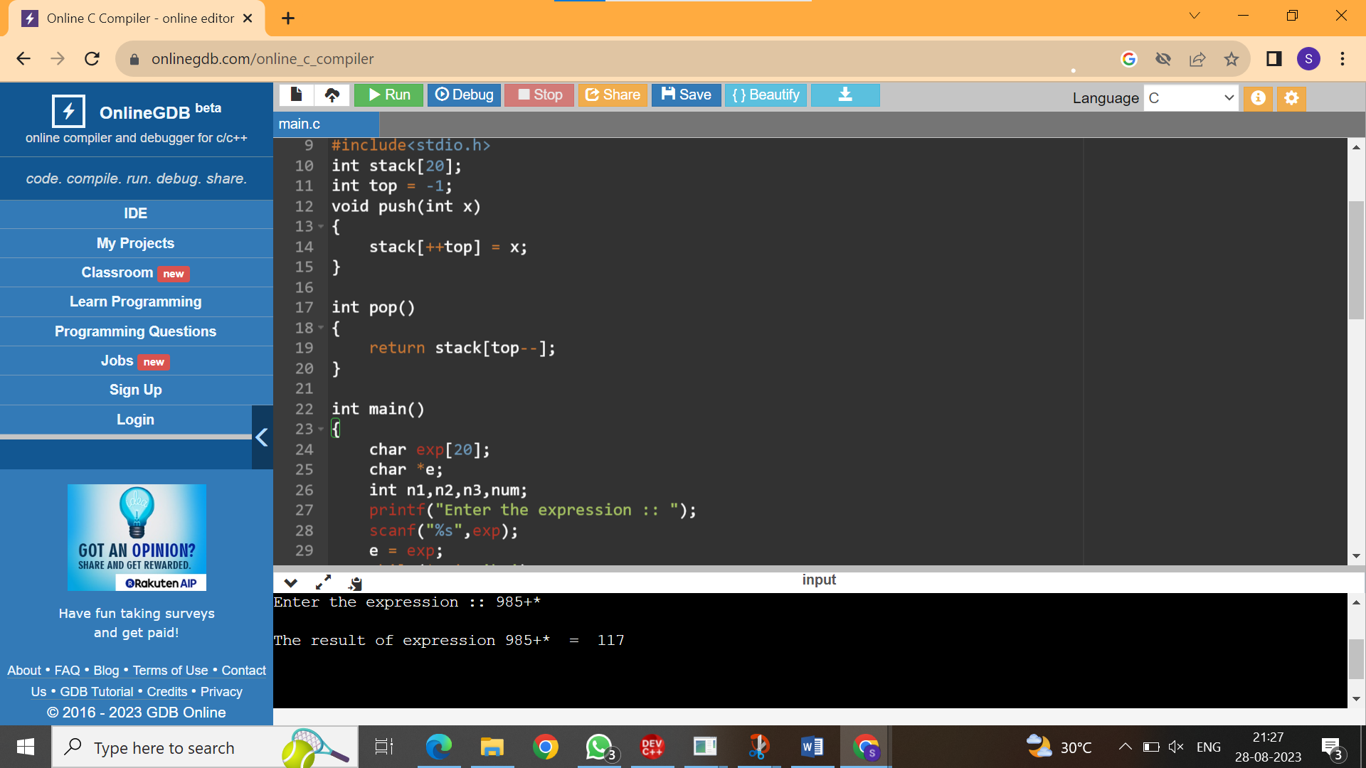

Sample input: 985+*

Output: 117

7.write a c program to implement tree traversals.

Program:

#include <stdio.h>

#include <stdlib.h>

struct Node {

int data;

struct Node* left;

struct Node* right;

};

struct Node* createNode(int data) {

struct Node* newNode = (struct Node*)malloc(sizeof(struct Node));

newNode->data = data;

newNode->left = NULL;

newNode->right = NULL;

return newNode;

}

void inorder(struct Node* root) {

if (root == NULL)

return;

inorder(root->left);

printf("%d ", root->data);

inorder(root->right);

}

void preorder(struct Node* root) {

if (root == NULL)

return;

printf("%d ", root->data);

preorder(root->left);

preorder(root->right);

}

void postorder(struct Node* root) {

if (root == NULL)

return;

postorder(root->left);

postorder(root->right);

printf("%d ", root->data);

}

int main() {

struct Node* root = createNode(1);

root->left = createNode(2);

root->right = createNode(3);

root->left->left = createNode(4);

root->left->right = createNode(5);

printf("Inorder traversal: ");

inorder(root);

printf("\n");

printf("Preorder traversal: ");

preorder(root);

printf("\n");

printf("Postorder traversal: ");

postorder(root);

printf("\n");

return 0;

}

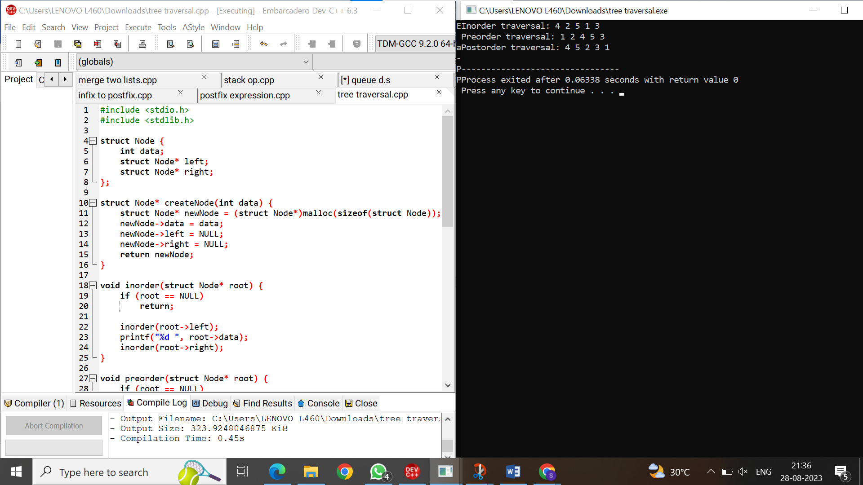

Sample input:

Inorder traversal

Preorder traversal

Postorder traversal

Output:

Inorder: 4 2 5 1 3

Preorder: 1 2 4 5 3

Postorder: 4 5 2 3 1

Day 4: DATA STRUCTURES PROGRAMS

1.write a c program to implement binary search tree.

Program:

#include <stdio.h>

#include <stdlib.h>

struct Node {

int data;

struct Node* left;

struct Node* right;

};

struct Node* createNode(int data) {

struct Node* newNode = (struct Node*)malloc(sizeof(struct Node));

newNode->data = data;

newNode->left = NULL;

newNode->right = NULL;

return newNode;

}

struct Node* insert(struct Node* root, int data) {

if (root == NULL) {

return createNode(data);

}

if (data < root->data) {

root->left = insert(root->left, data);

} else if (data > root->data) {

root->right = insert(root->right, data);

}

return root;

}

void inOrderTraversal(struct Node* root) {

if (root != NULL) {

inOrderTraversal(root->left);

printf("%d ", root->data);

inOrderTraversal(root->right);

}

}

int main() {

struct Node* root = NULL;

int n, value;

printf("Enter the number of elements: ");

scanf("%d", &n);

printf("Enter the elements:\n");

for (int i = 0; i < n; i++) {

scanf("%d", &value);

root = insert(root, value);

}

printf("In-order traversal of the binary search tree: ");

inOrderTraversal(root);

printf("\n");

return 0;

}

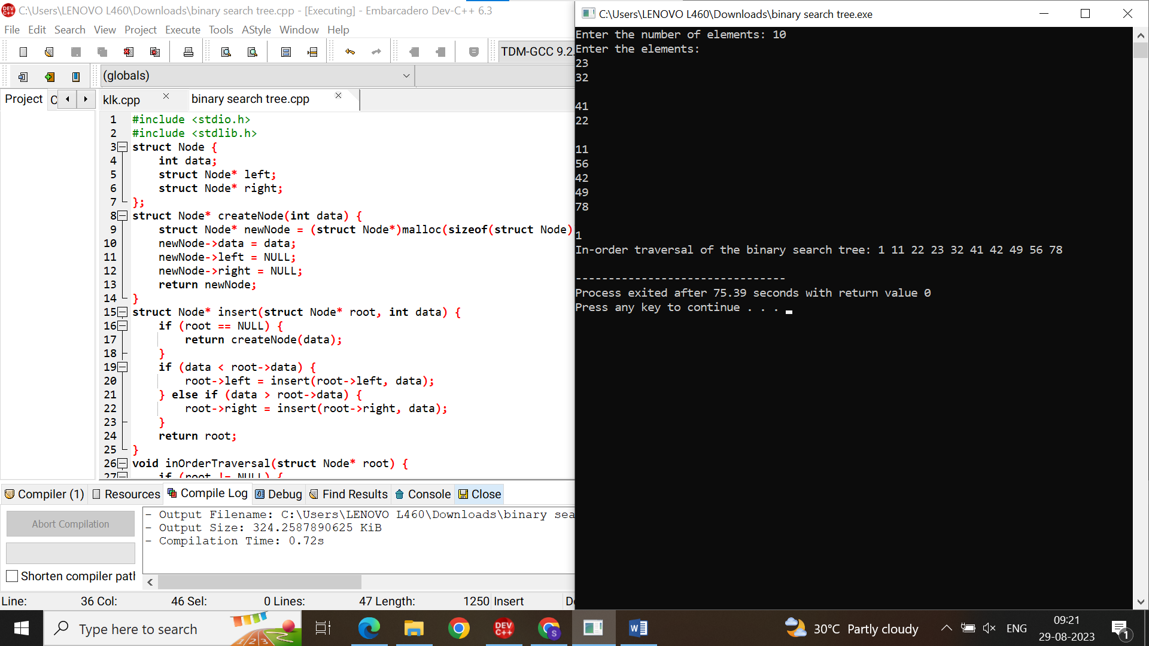Sample input:elements:23,32,41,22,11,56,42,49,78,1 Output:inorder:1,11,22,23,32,41,42,49,56,78.

2.write a c program to implement AVL tree.

Program:

4.write a c program to implement bubble sort.

Program:

#include<stdio.h>

int main(){

int n;

printf("Enter the size of the array: ");

scanf("%d", &n);

int a[n];

printf("Enter the elements: ");

for(int i = 0; i < n; i++){

scanf("%d", &a[i]);

}

int c=1;

while(c<n){

for(int j=0;j<n-c;j++){

if(a[j]>a[j+1]){

int temp=a[j];

a[j]=a[j+1];

a[j+1]=temp;

}

}

c++;

}

for(int i=0;i<n;i++){

printf("%d\t", a[i]);

}

return 0;

}

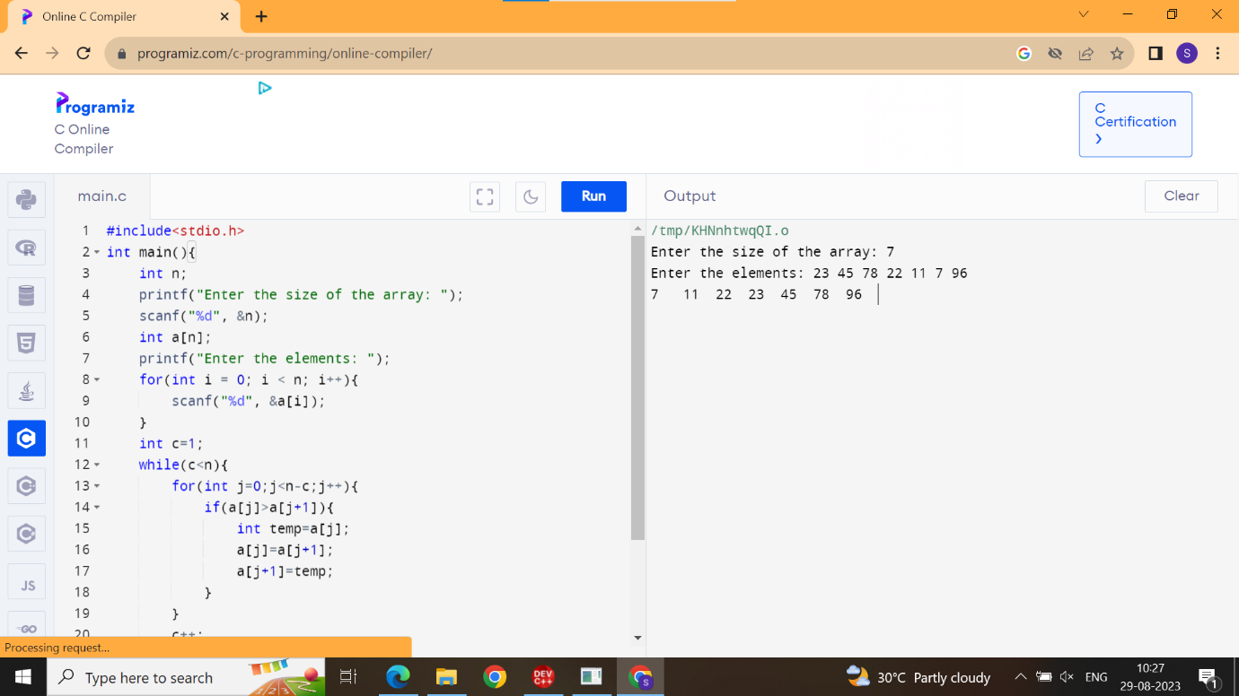

Sample input:

Enter the size of array: 7

Enter the elements: 23 45 78 22 11 7 96

Output:

7 11 22 23 45 78 96

5.write a c program to implement insertion sort.

Program:

#include <stdio.h>

int main(void)

{

int n, i, j, temp;

int arr[64];

printf("Enter number of elements\n");

scanf("%d", &n);

printf("Enter %d integers\n", n);

for (i = 0; i < n; i++)

{

scanf("%d", &arr[i]);

}

for (i = 1; i < n; i++)

{

j = i;

while (j > 0 && arr[j - 1] > arr[j])

{

temp = arr[j];

arr[j] = arr[j - 1];

arr[j - 1] = temp;

j--;

}

}

printf("Sorted list in ascending order:\n");

for (i = 0; i < n; i++)

{

printf("%d\n", arr[i]);

}

return 0;

}

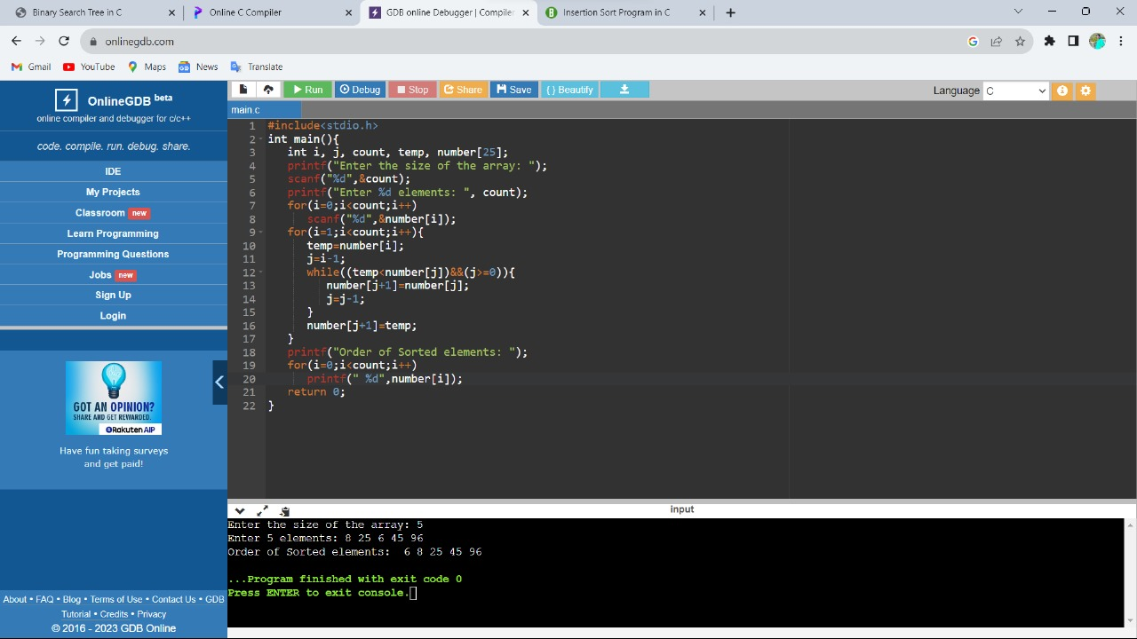

Sample input: size:5

Integers: 34 21 73 1 22

Output: 1 21 22 34 73

6.write a c program to implement selection sort.

Program:

#include<stdio.h>

int main(){

int i, j, count, temp, number[25];

printf("How many numbers u are going to enter?: ");

scanf("%d",&count);

printf("Enter %d elements: ", count);

for(i=0;i<count;i++)

scanf("%d",&number[i]);

for(i=0;i<count;i++){

for(j=i+1;j<count;j++){

if(number[i]>number[j]){

temp=number[i];

number[i]=number[j];

number[j]=temp;

}

}

}

printf("Sorted elements: ");

for(i=0;i<count;i++)

printf(" %d",number[i]);

   return 0;

}

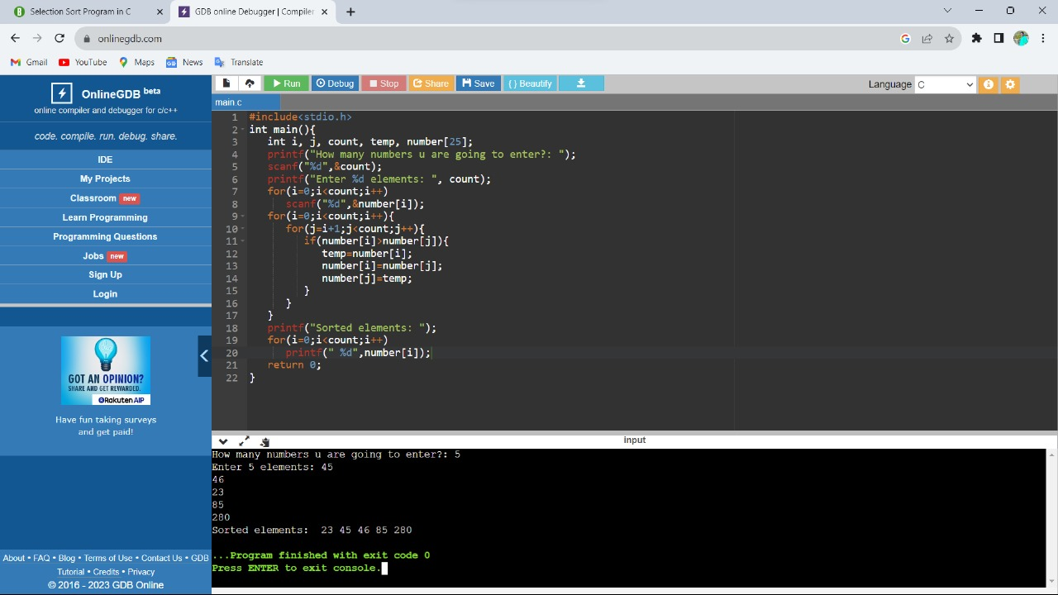

Sample input: size 5

Integers: 18 4 23 9 19

Output: 4 9 18 19 23

7.write a c program to implement quick sort.

Program:

#include<stdio.h>

void quicksort(int number[25],int first,int last){

int i, j, pivot, temp;

if(first<last){

pivot=first;

i=first;

j=last;

while(i<j){

while(number[i]<=number[pivot]&&i<last)

i++;

while(number[j]>number[pivot])

j--;

if(i<j){

temp=number[i];

number[i]=number[j];

number[j]=temp;

}

}

temp=number[pivot];

number[pivot]=number[j];

number[j]=temp;

quicksort(number,first,j-1);

quicksort(number,j+1,last);

}

}

int main(){

int i, count, number[25];

printf("How many elements are u going to enter?: ");

scanf("%d",&count);

printf("Enter %d elements: ", count);

for(i=0;i<count;i++)

scanf("%d",&number[i]);

quicksort(number,0,count-1);

printf("Order of Sorted elements: ");

for(i=0;i<count;i++)

printf(" %d",number[i]);

   return 0;

}

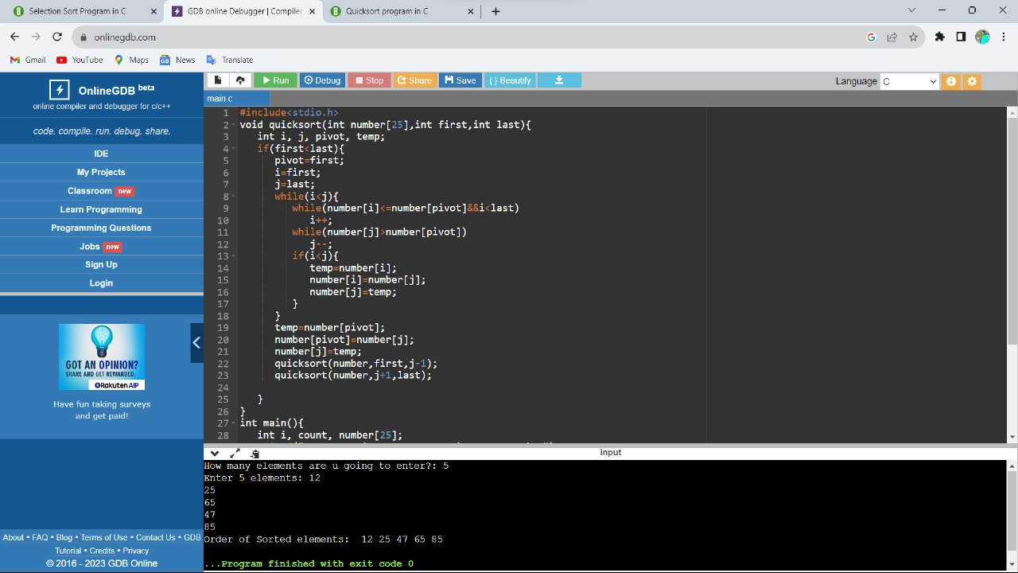Sample input: 12 25 65 47 85 Output: 12 25 47 65 85

8.write a c program to implement merge sort.

Program:

#include <stdio.h>

void merge(int arr[], int left, int mid, int right) {

int i, j, k;

int n1 = mid - left + 1;

int n2 = right - mid;

int L[n1], R[n2];

for (i = 0; i < n1; i++)

L[i] = arr[left + i];

for (j = 0; j < n2; j++)

R[j] = arr[mid + 1 + j];

i = 0;

j = 0;

k = left;

while (i < n1 && j < n2) {

if (L[i] <= R[j]) {

arr[k] = L[i];

i++;

} else {

arr[k] = R[j];

j++;

}

k++;

}

while (i < n1) {

arr[k] = L[i];

i++;

k++;

}

while (j < n2) {

arr[k] = R[j];

j++;

k++;

}

}

void mergeSort(int arr[], int left, int right) {

if (left < right) {

int mid = left + (right - left) / 2;

mergeSort(arr, left, mid);

mergeSort(arr, mid + 1, right);

merge(arr, left, mid, right);

}

}

int main() {

int n;

printf("Enter the number of elements: ");

scanf("%d", &n);

int arr[n];

printf("Enter %d elements:\n", n);

for (int i = 0; i < n; i++) {

scanf("%d", &arr[i]);

}

mergeSort(arr, 0, n - 1);

printf("Sorted array:\n");

for (int i = 0; i < n; i++) {

printf("%d ", arr[i]);

}

printf("\n");

return 0;

}

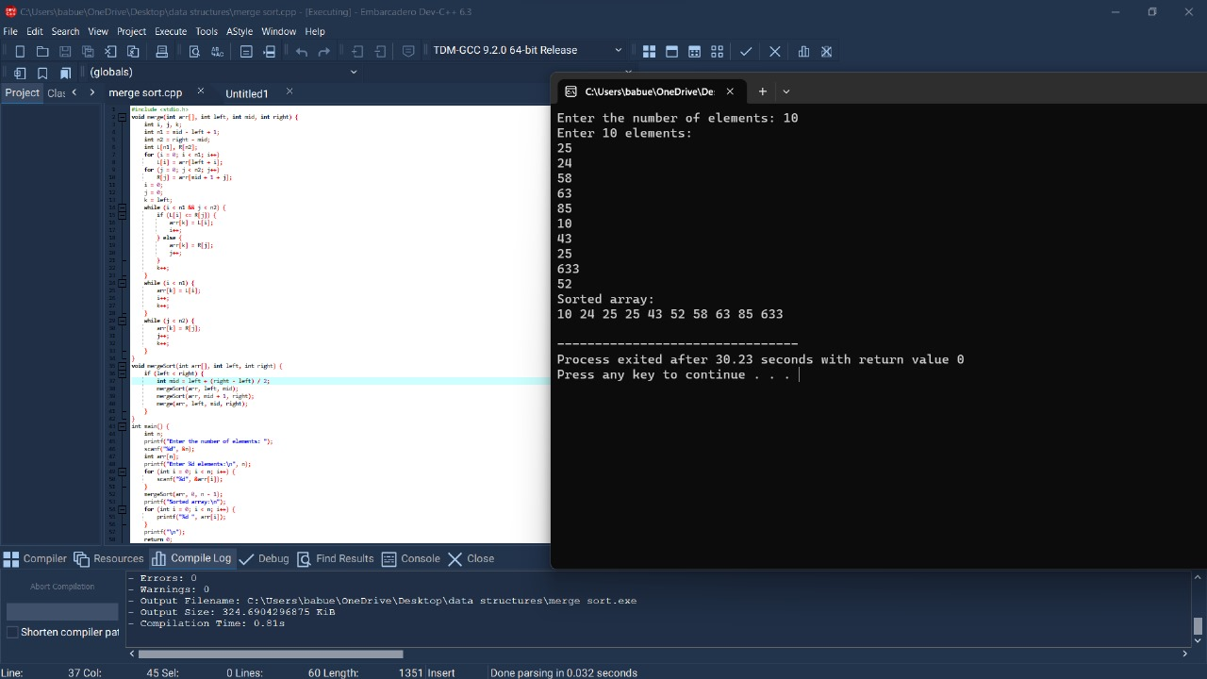

Sample input:

Size=5

Elements= 23 11 46 22 9

Output: 9 11 22 23 46.

DAY - 5 DATA STRUCTURES PROGRAMS:

1. Write a c program to implement single source shortest algorithm(Dijistra’s)?

Code:

#include<stdio.h>

#include<conio.h>

#define INFINITY 9999

#define MAX 10

void dijkstra(int G[MAX][MAX],int n,int startnode);

int main()

{

int G[MAX][MAX],i,j,n,u;

printf("Enter no. of vertices:");

scanf("%d",&n);

printf("\nEnter the adjacency matrix:\n");

for(i=0;i<n;i++)

for(j=0;j<n;j++)

scanf("%d",&G[i][j]);

printf("\nEnter the starting node:");

scanf("%d",&u);

dijkstra(G,n,u);

return 0;

}

void dijkstra(int G[MAX][MAX],int n,int startnode)

{

int cost[MAX][MAX],distance[MAX],pred[MAX];

int visited[MAX],count,mindistance,nextnode,i,j;

for(i=0;i<n;i++)

for(j=0;j<n;j++)

if(G[i][j]==0)

cost[i][j]=INFINITY;

else

cost[i][j]=G[i][j];

for(i=0;i<n;i++)

{

distance[i]=cost[startnode][i];

pred[i]=startnode;

visited[i]=0;

}

distance[startnode]=0;

visited[startnode]=1;

count=1;

while(count<n-1)

{

mindistance=INFINITY;

for(i=0;i<n;i++)

if(distance[i]<mindistance&&!visited[i])

{

mindistance=distance[i];

nextnode=i;

}

visited[nextnode]=1;

for(i=0;i<n;i++)

if(!visited[i])

if(mindistance+cost[nextnode][i]<distance[i])

{

distance[i]=mindistance+cost[nextnode][i];

pred[i]=nextnode;

}

count++;

}

for(i=0;i<n;i++)

if(i!=startnode)

{

printf("\nDistance of node%d=%d",i,distance[i]);

printf("\nPath=%d",i);

j=i;

do

{

j=pred[j];

printf("<-%d",j);

}while(j!=startnode);

}

}

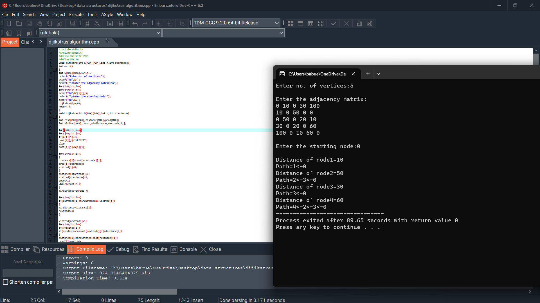

1. Write a c program to implement minimum spanning tree from prim’s algorithm?

Code:

#include <stdio.h>

#include <stdlib.h>

#include <limits.h>

#define V 5

int minKey(int key[], int mstSet[]) {

int min = INT_MAX, min_index;

for (int v = 0; v < V; v++) {

if (!mstSet[v] && key[v] < min) {

min = key[v];

min_index = v;

}

}

return min_index;

}

void printMST(int parent[], int graph[V][V]) {

printf("Edge Weight\n");

for (int i = 1; i < V; i++) {

printf("%d - %d %d \n", parent[i], i, graph[i][parent[i]]);

}

}

void primMST(int graph[V][V]) {

int parent[V];

int key[V];

int mstSet[V];

for (int i = 0; i < V; i++) {

key[i] = INT_MAX;

mstSet[i] = 0;

}

key[0] = 0;

parent[0] = -1;

for (int count = 0; count < V - 1; count++) {

int u = minKey(key, mstSet);

mstSet[u] = 1;

for (int v = 0; v < V; v++) {

if (graph[u][v] && !mstSet[v] && graph[u][v] < key[v]) {

parent[v] = u;

key[v] = graph[u][v];

}

}

}

printMST(parent, graph);

}

int main() {

int graph[V][V];

printf("Enter the adjacency matrix for the graph:\n");

for (int i = 0; i < V; i++) {

for (int j = 0; j < V; j++) {

scanf("%d", &graph[i][j]);

}

}

primMST(graph);

return 0;

}

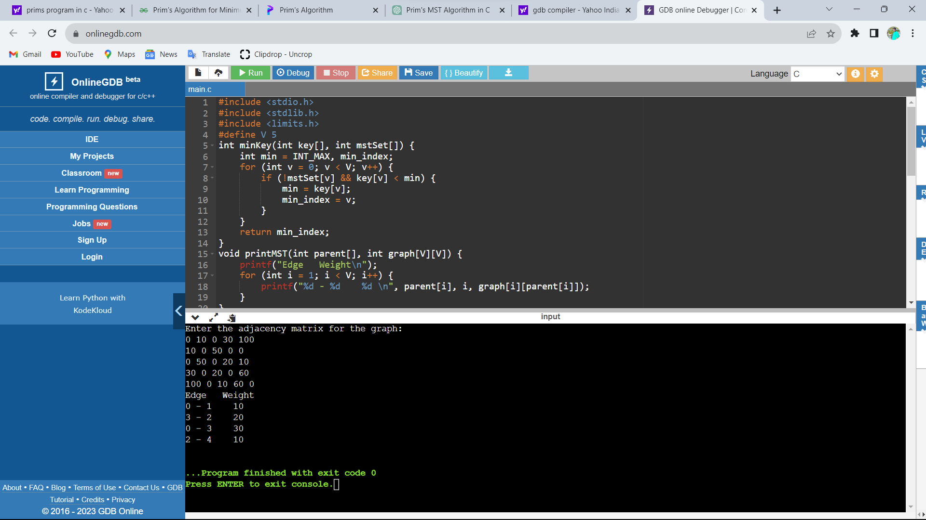

1. Write a c program to implement Kruskal’s algorithm?

Code:

#include <stdio.h>

#include <stdlib.h>

int comparator(const void* p1, const void* p2)

{

const int(*x)[3] = p1;

const int(*y)[3] = p2;

return (*x)[2] - (*y)[2];

}

void makeSet(int parent[], int rank[], int n)

{

for (int i = 0; i < n; i++) {

parent[i] = i;

rank[i] = 0;

}

}

int findParent(int parent[], int component)

{

if (parent[component] == component)

return component;

return parent[component]

= findParent(parent, parent[component]);

}

void unionSet(int u, int v, int parent[], int rank[], int n)

{

u = findParent(parent, u);

v = findParent(parent, v);

if (rank[u] < rank[v]) {

parent[u] = v;

}

else if (rank[u] > rank[v]) {

parent[v] = u;

}

else {

parent[v] = u;

rank[u]++;

}

}

void kruskalAlgo(int n, int edge[n][3])

{

qsort(edge, n, sizeof(edge[0]), comparator);

int parent[n];

int rank[n];

makeSet(parent, rank, n);

int minCost = 0;

printf(

"Following are the edges in the constructed MST\n");

for (int i = 0; i < n; i++) {

int v1 = findParent(parent, edge[i][0]);

int v2 = findParent(parent, edge[i][1]);

int wt = edge[i][2];

if (v1 != v2) {

unionSet(v1, v2, parent, rank, n);

minCost += wt;

printf("%d -- %d == %d\n", edge[i][0],

edge[i][1], wt);

}

}

printf("Minimum Cost Spanning Tree: %d\n", minCost);

}

int main()

{

int edge[5][3] = { { 0, 1, 10 },

{ 0, 2, 6 },

{ 0, 3, 5 },

{ 1, 3, 15 },

{ 2, 3, 4 } };

kruskalAlgo(5, edge);

return 0;

}

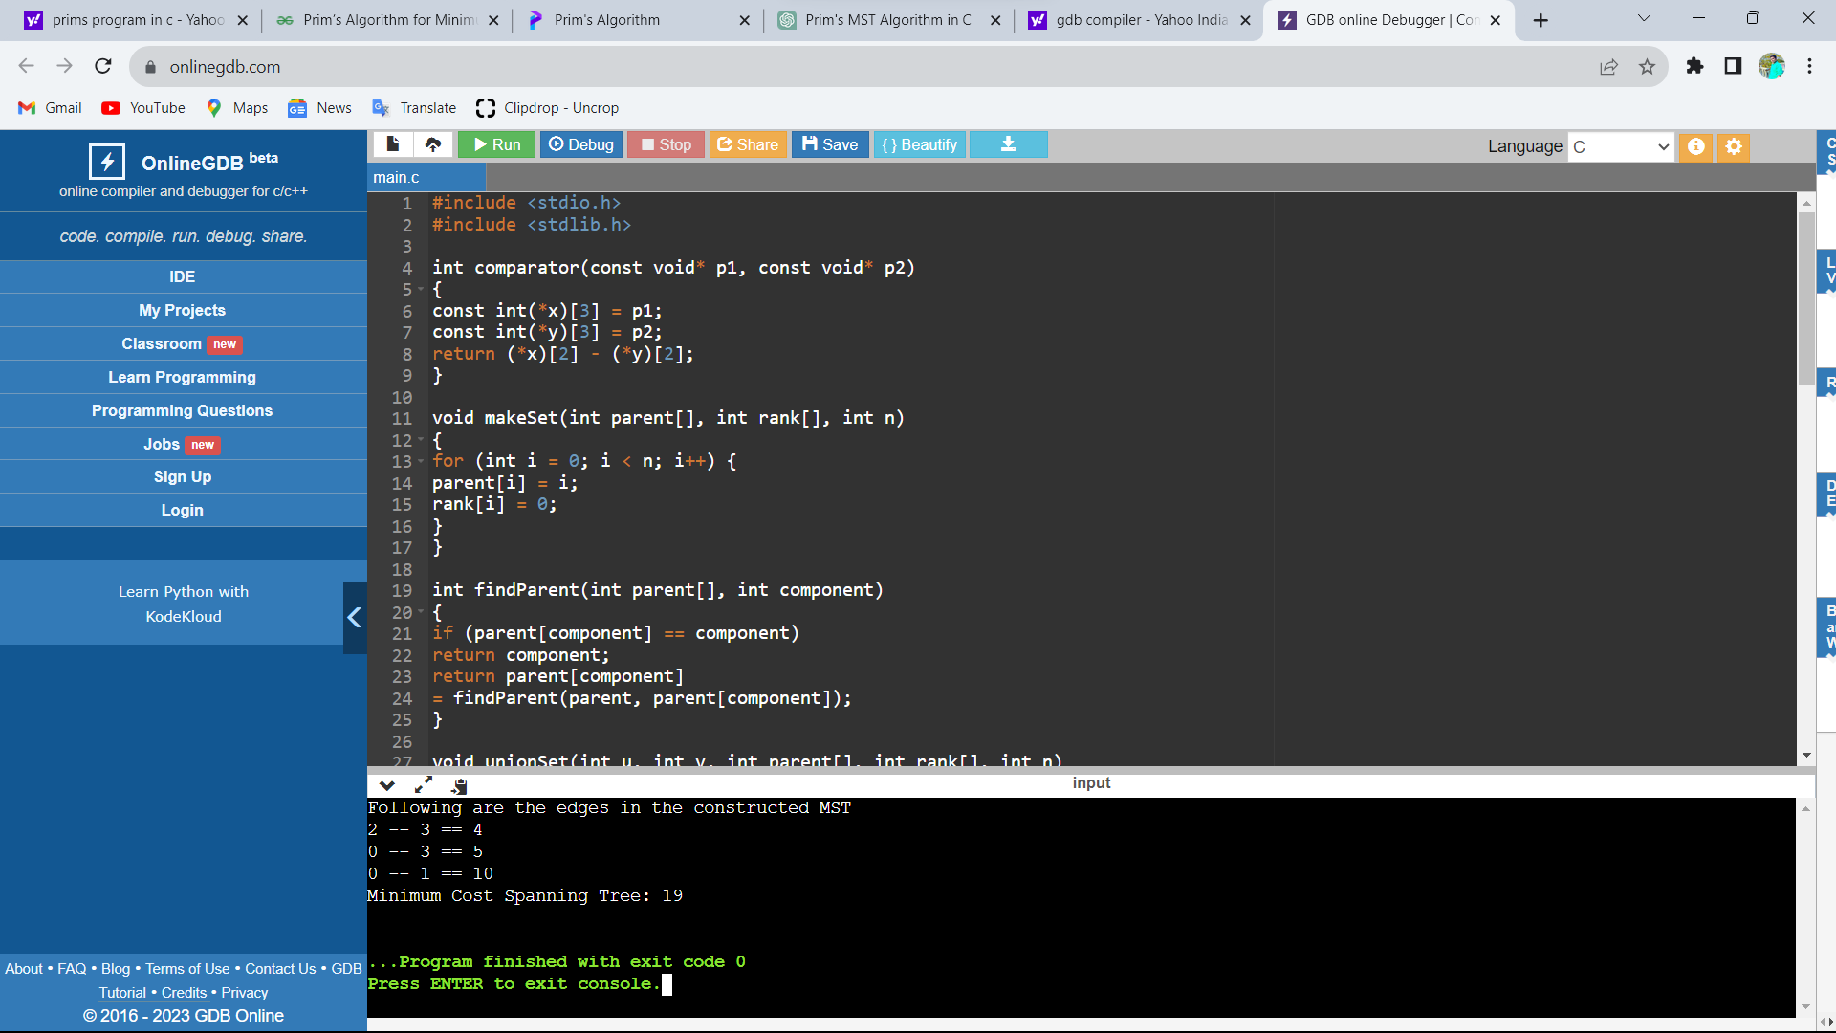

1. Write a c program to implement the graph traversals?

Code:

#include <stdio.h>

#include <stdlib.h>

struct node

{

int vertex;

struct node *next;

};

struct node *createNode(int);

struct Graph

{

int numVertices;

struct node **adjLists;

int *visited;

};

struct Graph *createGraph(int vertices)

{

struct Graph *graph = malloc(sizeof(struct Graph));

graph->numVertices = vertices;

graph->adjLists = malloc(vertices * sizeof(struct node *));

graph->visited = malloc(vertices * sizeof(int));

int i;

for (i = 0; i < vertices; i++)

{

graph->adjLists[i] = NULL;

graph->visited[i] = 0;

}

return graph;

}

void addEdge(struct Graph *graph, int src, int dest)

{

struct node *newNode = createNode(dest);

newNode->next = graph->adjLists[src];

graph->adjLists[src] = newNode;

newNode = createNode(src);

newNode->next = graph->adjLists[dest];

graph->adjLists[dest] = newNode;

}

struct node *createNode(int v)

{

struct node *newNode = malloc(sizeof(struct node));

newNode->vertex = v;

newNode->next = NULL;

return newNode;

}

void printGraph(struct Graph *graph)

{

int v;

for (v = 0; v < graph->numVertices; v++)

{

struct node *temp = graph->adjLists[v];

printf("\n Adjacency list of vertex %d\n ", v);

while (temp)

{

printf("%d -> ", temp->vertex);

temp = temp->next;

}

printf("\n");

}

}

void bfs(struct Graph *graph, int startVertex)

{

struct node *queue = NULL;

graph->visited[startVertex] = 1;

enqueue(&queue, startVertex);

while (!isEmpty(queue))

{

printQueue(queue);

int currentVertex = dequeue(&queue);

printf("Visited %d ", currentVertex);

struct node *temp = graph->adjLists[currentVertex];

while (temp)

{

int adjVertex = temp->vertex;

if (graph->visited[adjVertex] == 0)

{

graph->visited[adjVertex] = 1;

enqueue(&queue, adjVertex);

}

temp = temp->next;

}

}

}

int isEmpty(struct node *queue)

{

return queue == NULL;

}

void enqueue(struct node **queue, int value)

{

struct node *newNode = createNode(value);

if (isEmpty(*queue))

{

*queue = newNode;

}

else

{

struct node *temp = *queue;

while (temp->next)

{

temp = temp->next;

}

temp->next = newNode;

}

}

int dequeue(struct node **queue)

{

int nodeData = (*queue)->vertex;

struct node *temp = *queue;

*queue = (*queue)->next;

free(temp);

return nodeData;

}

void printQueue(struct node *queue)

{

while (queue)

{

printf("%d ", queue->vertex);

queue = queue->next;

}

printf("\n");

}

int main(void)

{

struct Graph *graph = createGraph(6);

printf("\nWhat do you want to do?\n");

printf("1. Add edge\n");

printf("2. Print graph\n");

printf("3. BFS\n");

printf("4. Exit\n");

int choice;

scanf("%d", &choice);

while (choice != 4)

{

if (choice == 1)

{

int src, dest;

printf("Enter source and destination: ");

scanf("%d %d", &src, &dest);

addEdge(graph, src, dest);

}

else if (choice == 2)

{

printGraph(graph);

}

else if (choice == 3)

{

int startVertex;

printf("Enter starting vertex: ");

scanf("%d", &startVertex);

bfs(graph, startVertex);

}

else

{

printf("Invalid choice\n");

}

printf("What do you want to do?\n");

printf("1. Add edge\n");

printf("2. Print graph\n");

printf("3. BFS\n");

printf("4. Exit\n");

scanf("%d", &choice);

}

return 0;

}

